The flu virus kills 11,000 people and hospitalises tens of thousands more in England in an average year. But with COVID-19 in circulation, this is anything but an average year.

GP practices in north east London are at the forefront of the flu programme – vaccinating a substantial portion of eligible residents this winter. In addition to a public-facing campaign across north east London that uplifts the National campaign, we need GP practices to continue to have meaningful conversations with at-risk patients about the importance of getting the flu vaccine this year.

To help support your conversations with at-risk patients, we have put together a toolkit of resources for GP practices to use.

Who do we need to speak to?

In north east London last year, only half of those eligible for the flu vaccine chose to get vaccinated. Uptake was higher in those aged 65 and over. However, it was significantly lower in at-risk groups for pregnant women, children aged 2 and 3 years old, and those living with long-term health conditions.

To address this, we are delivering targeted communications and engagement across north east London to focus on these low uptake groups. We are asking GP practices to consider how they speak to patients in these at-risk groups as we aim to reach the 75% target across north east London.

 | Total | 65 and  Over | Under 65 at Risk Only | 2 years  old | 3 years  old | Pregnant Women | Carers  (5-16) | Carers  (17+)
City and Hackney | 45% | 64% | 41% | 23% | 22% | 32% | 8% | 27%
Tower Hamlets | 50% | 70% | 47% | 29% | 31% | 44% | 15% | 31%
Newham | 49% | 66% | 47% | 28% | 28% | 44% | 10% | 32%
Waltham Forest | 46% | 65% | 38% | 30% | 29% | 39% | 10% | 21%
Barking and Dagenham | 49% | 65% | 46% | 26% | 30% | 41% | 15% | 34%
Havering | 57% | 70% | 42% | 33% | 34% | 40% | 17% | 40%
Redbridge | 52% | 68% | 44% | 27% | 29% | 41% | 18% | 35%
NEL STP | 50% | 67% | 44% | 28% | 29% | 40% | 11% | 31%

How can practices help?

We have put together a toolkit of resources to make starting conversations with patients easier.

Whether you speak to your patients on social media, closed messaging platforms (like WhatsApp), or through an email newsletter or website – we have ‘one stop shop’ of images and information that will best suit how you want to talk to patients about the flu.

To join the flu vaccination conversation and help the NHS to talk to those most at risk:

- Look through the toolkit to find the most appropriate resource for your practice.
- Post on Facebook, Twitter, WhatsApp, websites or blogs – wherever your audiences is – to help spread awareness of the importance of the flu vaccine.

Toolkit

Information leaflet, translations and easy read guide:
- The main flu leaflet Flu vaccination 20/21: Who should have it and why can be downloaded from the gov.uk website.
- Do you need this leaflet in another format? Translated leaflets and easy read guides for people with learning disabilities explaining eligibility are available now. Audio, braille, large print and British Sign Language formats coming soon.

Printed resources:
Available in mid-October. Public Health England will be released a series of printed posters aimed at pregnant women, those living with long-term health conditions, and parents with children aged two and three years old.

For websites:
Practices are encouraged to update their website with patient information about current flu campaign. You can use the following copy/text on your website.

Standard copy –

“Just” the flu?
Each year the flu kills on average 11,000 people and hospitalises thousands more. There’s no “just” about it.
The flu virus spreads from person to person. Even amongst those not showing symptoms.
The flu vaccine is the best protection for you and those around you and it’s available for free to those most at risk.
A flu vaccine is available for free on the NHS for the following:
- Pregnant women
- Parents of children aged 2-11 years old
- Members of a shielding household
- 65+ years old
- Frontline health and social care workers
- Those living with a long-term health condition, such as:
  - a heart problem
  - a chest complaint or breathing difficulties, including bronchitis, emphysema or severe asthma
  - kidney disease
  - lowered immunity due to disease or treatment (such as steroid medication or cancer treatment)
  - liver disease
  - had a stroke or a transient ischaemic attack (TIA) ·
  - diabetes
  - a neurological condition, e.g. multiple sclerosis (MS), cerebral palsy ·
  - a learning disability
  - a problem with your spleen, e.g. sickle cell disease, or you have had your spleen removed
  - are seriously overweight (BMI of 40 and above)
Dr ____, said: “The flu is not the same as getting a cold. It can seriously affect your health and the risks of developing complications are greater for people within the ‘at-risk’ groups. Healthy individuals usually recover within two to seven days, but for some the disease can lead to a stay in hospital, or even death. In this unprecedented year, it is vital that we do all we can to protect ourselves and others from the virus this winter.” Find out more.

Frequently Asked Questions copy –

Are you considering not getting the flu vaccine this year? Or is there something about it that concerns you? Read below for more information on why it’s good to get vaccinated, and how to find out more.

Is the flu vaccination safe? The flu vaccination is safe and effective and must be given annually. It cannot give you the flu. It does not protect you from COVID-19 or seasonal coughs and colds, but it does give protection against the strains of flu virus that will be circulating this year. Adults usually receive the flu vaccination in injection form, and children usually receive a nasal spray.

When can I get the flu vaccination? We expect that the flu vaccination will be available from autumn 2020 onwards. You will be invited to book a vaccination appointment at around this time, but please contact your GP practice if not. It’s important that you have your vaccination as soon as possible.

Where can I get the flu vaccination? Many people will receive their flu vaccination at a GP surgery as usual. Others may go to a pharmacy or another location in their community. School-aged children will receive their vaccination from a trained health professional at school or in their community. Health professionals will also vaccinate care home staff and residents on-site.

Is it safe to attend appointments at health clinics? The NHS is doing everything it can to make sure that vaccinations are given in safe environments. All possible precautions will be taken to make sure you, and staff, are protected. If you have COVID-19 symptoms, do not attend your vaccination appointment but instead self-isolate and book a coronavirus test at nhs.uk/coronavirus or by calling119. You can rebook your flu vaccination appointment at a later date.

How will I know if I have the flu or COVID-19? The flu virus and COVID-19 have symptoms which overlap, such a high temperature or persistent cough. It may be difficult to tell which virus you have. For this reason, it’s really important that you have a flu vaccination if you are eligible, and that you continue to follow the guidance on self-isolation and testing at nhs.uk/coronavirus if you have any of the symptoms of COVID-19.

Can you catch flu from the vaccine? No, the vaccine contains an inactivated virus which cannot give you flu.

Does the flu vaccine cause serious side effects? Only one in a million people get serious side effects. Mild side effects such as soreness around the injection site and aching muscles are more common, but these are far less serious than the effects of contracting flu.

Is flu just like having a bad cold? Flu is a very serious illness which kills 11,000 people a year and hospitalises many more. It can lead to severe complications including pneumonia and organ failure.

Does the nasal vaccine/spray contain gelatine? Yes, the nasal vaccine contains a highly processed form of gelatine (porcine gelatine), which is used in a range of essential medicines. The gelatine helps to keep the vaccine viruses stable so that the vaccine provides the best protection against flu. The nasal vaccine is offered to children, as it is more effective in the programme than the injected vaccine. This is because it is easier to administer and considered better at reducing the spread of flu to others, who may be more vulnerable to the complications of flu. However, if your child is at high risk from flu due to one or more medical conditions or treatments and can’t have the nasal flu vaccine, they should have the flu vaccine by injection. Some people may not accept the use of porcine gelatine in medical products. You should discuss your options with your nurse or doctor.

I’ve been vaccinated before so do I need to do it again? The flu virus mutates constantly, and the vaccine is updated every year to counter the latest strains so it is important to get vaccinated annually.

I’m healthy. Do I need to get vaccinated? Flu can cause serious illness or death in healthy people. Getting vaccinated reduces your chance of catching flu by 40-60%.

I’m pregnant. Should I get vaccinated? The flu vaccine is safe at any stage of pregnancy, and is recommended for all pregnant women as they face a higher risk of developing complications from flu.
Can I book online? This year eligible Londoners will be able to book their flu vaccine online with their local pharmacist at londonflu.co.uk. Londoners are also able to walk in to pharmacies and get the vaccine.

For bulletins and newsletters:
Practices are encouraged to promote the flu campaign within their local community. The following short article, which is a more general article about the flu can be used in Practice newsletters or local community newsletters.

Each year the flu kills around 11,000 people and hospitalises thousands more. This year it’s more important than ever for people at risk to get their free flu vaccine. If you’re over 65, are pregnant, have a long-term health condition, or you’re in a shielding household, speak to your GP or pharmacist to get the free flu vaccine. You can book online with your local pharmacist at londonflu.co.uk. Children aged 2-3 can get a free nasal spray at their GP. School aged children up to year 7 will be offered the vaccine at school – if you have an eligible child, please make sure they get it to help stop the spread of flu. The flu spreads from person to person – even amongst those not showing symptoms. The vaccine is the best protection for you and those around you. Find out more.

For social media:
Practices are encouraged to help raise awareness of the national flu campaign through their social media channels – Facebook, Twitter, and Instagram. You can use any of the following graphics and wording below for your accounts. Alternatively, please follow your local CCG Twitter accounts and retweet/share our activity.

Assets can be downloaded on the East London Health and Care Partnership website.

Twitter –
Copy | Image
1 – generic  It’s more important than ever to get the flu vaccine if you’re eligible this year. Measures are in place to keep you safe.  Find out more: https://www.england.nhs.uk/london/our-work/getting-the-flu-vaccine/ | 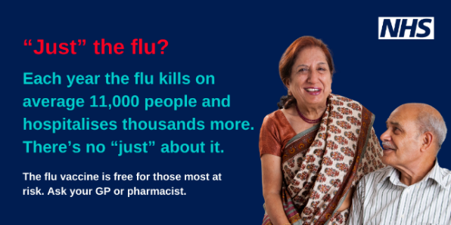
2 – long term health conditions  If you have a health condition like lung disease, diabetes or a heart problem, it’s important you protect yourself from flu this year. Ask your GP or pharmacist today.  Find out more: https://www.england.nhs.uk/london/our-work/getting-the-flu-vaccine/ | 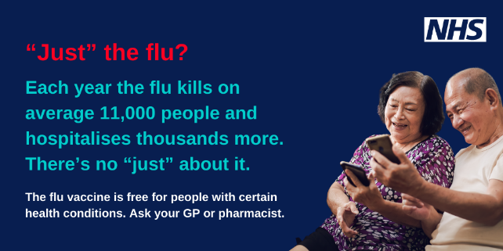
3 – parents of children aged 2-3  Flu can be horrible and sometimes serious for little ones. The free nasal spray vaccine is the best way to protect them and others from flu. If your child is 2 or 3, ask your GP today.  Find out more: https://www.england.nhs.uk/london/our-work/getting-the-flu-vaccine/ | 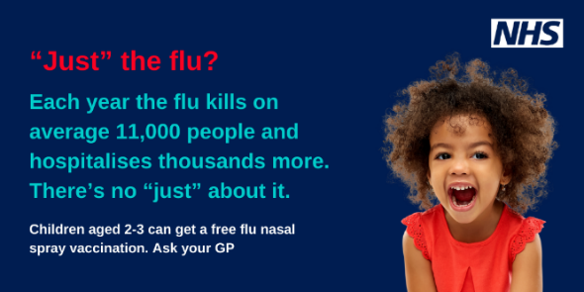
4 – pregnant  Flu can cause serious complications for you and your baby. The free flu vaccine is the best protection for both of you. Ask your GP or pharmacist.  Find out more: https://www.england.nhs.uk/london/our-work/getting-the-flu-vaccine/ | 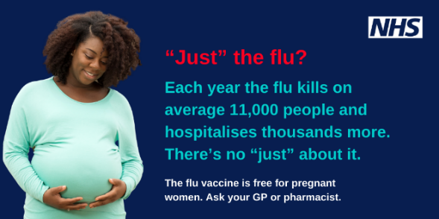

Facebook, Instagram, WhatsApp –
Copy | Example image
1 – generic  “Just” the flu?  Each year the flu kills on average 11,000 people and hospitalises thousands more. There’s no “just” about it.  It’s more important than ever to get the flu vaccine if you’re eligible this year. Measures are in place to keep you safe.  Find out more:  https://www.england.nhs.uk/london/our-work/getting-the-flu-vaccine/ | 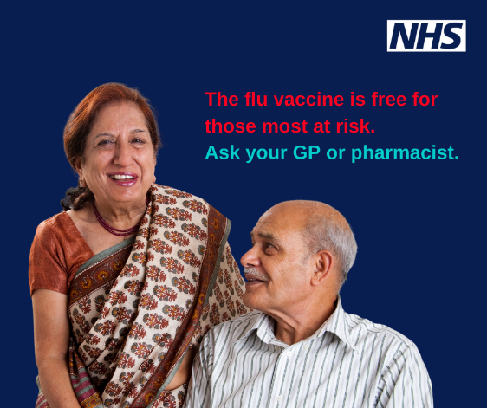
2 – long term health conditions  “Just” the flu?  Each year the flu kills on average 11,000 people and hospitalises thousands more. There’s no “just” about it.  If you have a health condition like lung disease, diabetes or a heart problem, it’s important you protect yourself from flu this year. Ask your GP or pharmacist today.  Find out more: https://www.england.nhs.uk/london/our-work/getting-the-flu-vaccine/ | 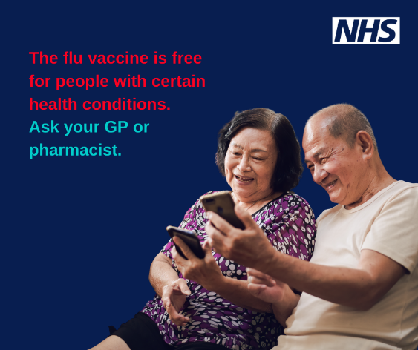
3 – parents of children aged 2-3  “Just” the flu?  Flu can be horrible and sometimes serious for little ones. There’s no “just” about it.  The free nasal spray vaccine is the best way to protect them and others from flu. If your child is 2 or 3, ask your GP today.  Find out more: https://www.england.nhs.uk/london/our-work/getting-the-flu-vaccine/ | 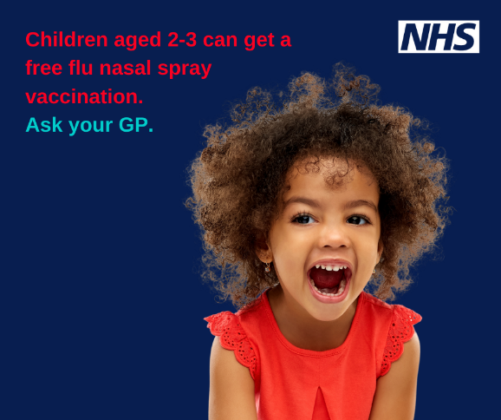
4 – pregnant  “Just” the flu?  Flu can cause serious complications for you and your baby. There’s no “just” about it.  The free flu vaccine is the best protection for both of you. Ask your GP or pharmacist.  Find out more: https://www.england.nhs.uk/london/our-work/getting-the-flu-vaccine/ | 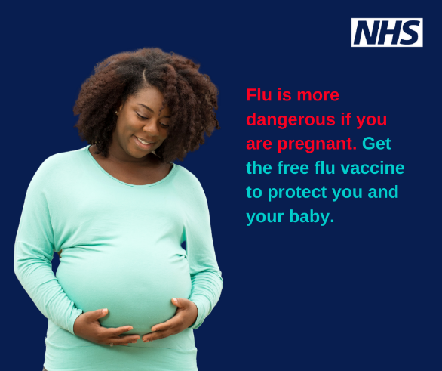

For creating a short video:
Practices are encouraged to create a short 60 second video to their patients about the importance of getting the flu vaccine. Often hearing the message from a trusted GP or practice nurse can help encourage patients to protect themselves. The following script can be used as a guide to help you make a short video.

It’s that time of year where we need to do all we can to protect ourselves from the flu virus.

I want to take a few moments of your time to talk to you about why it’s important to get the flu jab this year - to protect yourself and your family from the virus, especially those who may be vulnerable such as the elderly or those living with long-term health conditions.

Did you know that every year in the UK, the flu kills around 11,000 people and hospitalises thousands more? The flu is not just like having a bad cold. The virus is a highly contagious viral infection that anyone can catch, and it can be serious for many in our community.

This year, with Covid-19 in circulation, it’s more important than ever for those most at risk to get their free flu vaccine on the NHS.

If you’re over 65, are pregnant, are living with a long-term health condition such as diabetes, asthma, or heart disease; or if you’re a carer or living in a shielded household, I encourage you to speak to your GP or pharmacist about getting the free flu vaccine.

I believe the flu vaccine to be the best form of protection against the virus. It’s safe and effective. It cannot give you the flu. And is available in injection form for adults, and for young children by a pain-free nasal spray. Please take the time in the next few weeks to speak to your GP or pharmacist – and help spread the importance of getting the flu vaccine this year by talking to family and friends.

You might also want to mention –

Pork gelatine as an ingredient in the nasal spray –
Some people in our community may have concerns about an ingredient in the vaccine. For the nasal spray only – which is used to protect young children – it does contain a form of pork gelatine. This is used to keep the vaccine virus stable so that it can provide the best protection against flu. If you’re concerned about this – this shouldn’t stop you from discussing your options with your local GP or nurse.

Catching the flu from the vaccine –
Another concern some have is about catching the flu from the vaccine itself. I understand the vaccine to contain an inactivated virus which cannot give you the flu.

“I feel healthy” –
Some people at risk from the flu say they don’t need it. I understand flu can cause serious illness or death. Getting vaccinated is the best form of protection and reduces your chance of getting the flu by 40-60%.

Need anything else?

If you require any further resources to help support your flu campaign, please contact thccg.nelcommunications@nhs.net .

