COVID-19 PCR Swab Test

Information for employees

Reviewed 21st September 2020

This guidance is aimed at you as a health and social care employee, it tells you:
- How you can directly access a PCR swab test by having your employer refer you for PCR swab drive through / walk in or home test through the East London Health & Care Partnership offer.
- Who is eligible for testing;
- How to undertake the test;

NB. You need to get a PCR swab test done within the first 5 days of having symptoms. After that it is too late. You can get tested at a site or at home on days 1-4. If you are ordering a home test kit on day 4, do so by 3pm. On day 5, you need to go to a test site. It is too late to order a home test kit.

East London Health & Care Partnership PCR swab test offer
You will need to contact your employer to access a PCR swab test through this route.

Once referred bookings can be made at our drive-through / walk in sites at King George Hospital, Whipps Cross Hospital and Royal London Hospital or by booking a home test kit with us.

Home testing kits will be delivered one day and collected the next Monday to Friday each week by courier.

You are respectfully reminded that when booking a home test you must ensure someone is home and able to receive / pass the completed test back to the courier as booked. Failure to comply will result in the booking being void. If a home test is still required following a void your employer will have to refer you for PCR swab test again.

Eligibility:
This service is available to health and social care staff who live and work in NE London. The offer also applies to those staff who work in NE London, but live in the surrounding London boroughs of Greenwich, Lewisham, Southwark, Islington, Haringey, Bexley and Enfield together with the Brentwood Borough and Thurrock unitary councils who fit in the following criteria:
NHS and Social Care staff, and members of their household who have symptoms, whatever their age, have access to priority testing as part of this process. COVID-19 symptomatic children within the household of NHS or social care staff can be booked in to be tested. However, the parent/accompanying adult must perform the swab unless the child is of an age/ability where they can self-swab.
Staff at the test site will not perform PCR Swab tests on presenting adults or children.
If the parent does not feel comfortable swabbing their child they should not book the test.
See Guidance here: https://www.gov.uk/get-coronavirus-test

Information for health and social care staff using the East London Health & Care Partnership home testing offer

If you are self-isolating due to having at least one of the following symptoms:
- a high temperature – this means you feel hot to touch on your chest or back (you do not need to measure your temperature)
- a new, continuous cough – this means coughing a lot for more than an hour, or 3 or more coughing episodes in 24 hours (if you usually have a cough, it may be worse than usual)
- a loss or change to your sense of smell or taste – this means you've noticed you cannot smell or taste anything, or things smell or taste different to normal

And are eligible in line with national guidance, please use the process outlined below:

Step1 Once the kit(s) have been successfully ordered, they will be delivered within 24 hours by the designated courier service. Please ensure that you are at home to receive the kit(s).
Step 2 When the kits have been received, they must be checked to ensure they have not been tampered with and all test elements have been provided.
Step 3 The courier will look to return the following day to collect the completed test(s). All tests must be undertaken as close to the collection time as possible to ensure they are viable when tested.
Being at home at the point of drop off and collection Monday to Friday is important because we need to ensure the courier is not delayed and that the time window in between taking the swab and analysis is kept as small as possible.
Step by step instructions on how to complete the test can be found at https://www.youtube.com/watch?v=5qHTBlxfNes&feature=youtu.be.
Instructions on how to complete the test will also be provided in the kit.
Step 4 When packaging the kit for collection, it is important to follow the instructions provided with the kit and ensure that it is labelled and sealed correctly.
Step 5 ALL household samples must be ready at the same time and you MUST wait at home for your collection.
In order to observe the social distancing rules in place, when the courier arrives, they will knock on the door and then move at least 2 metres away. When they have moved away, please open your door, place the packaged test kit(s) outside your door, and close the door.
Step 6 The person tested will receive an email/text with the test results within 48 hours of the courier picking up the sample. The results will be sent to the provided mobile number or email address.

Home test pack contents
This is what the test kit contents looks like, with a numbered guide to each piece that indicates the sequence of how each item is used:
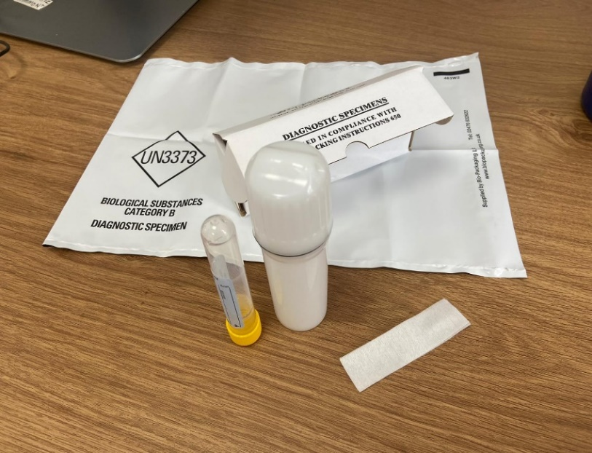
5
4
- Swab in packaging – inside is the swab. It looks like a long cotton bud.
- The small collection tube which you will use to hold the complete swab tip.
- The larger white screw-topped tube which is used to transport the small collection tube containing the swab.
- The cardboard box that the larger white screw-topped tube (containing the small collection tube housing the swab) is placed into.
- The plastic envelope that the cardboard box is placed into once the test is complete.

1
3
2

How to take a swab

https://www.youtube.com/watch?v=5qHTBlxfNes&feature=youtu.be.
