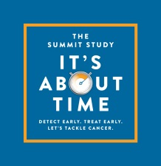
SUMMIT STUDY - THE STUDY TO DETECT LUNG CANCER EARLIER
UCLH and UCL recently announced plans to embark upon the largest ever lung cancer screening project in the UK.
One in two people will be diagnosed with cancer in their lifetime¹; lung cancer alone causes around 35,000 deaths per year in the UK. Early diagnosis is key to effective treatment and increasing survival for all cancers, but particularly for lung cancer: currently around 75% of lung cancers are diagnosed at a late stage - stages 3 and 4. If diagnosed at the earliest stage, 70% of lung cancer patients will survive for at least a year, compared to around 14% for people diagnosed with the most advanced stage of the disease².
The SUMMIT Study, beginning in spring 2019, has two aims: to detect lung cancer early using the proven method of low-dose CT (LDCT) screening of at-risk individuals; and to support development of a new blood test for early detection of multiple cancer types, including lung cancer. In addition, the study will provide evidence to inform a potential future national lung cancer screening programme. The study aims to recruit approximately 50,000 people aged 50-77 from north and east London.
How can my practice get involved?
UCLH and UCL are working closely with NOCLOR to engage GP practices in The SUMMIT Study. NOCLOR recently contacted practices in Camden with further information about the study and how to get involved. Practices can register their interest to participate directly with NOCLOR. Click here for further information about taking part as a practice. If you have any questions, contact the study team on uclh.HCPsummitstudy@nhs.net.

A payment of £250 will be provided for participation. The study would not disrupt your normal surgery routine.

