Safeguarding Team

Islington Directorate

Dr Alexandra Hirst Named GP for Child Safeguarding Islington

David Pennington Designated Professional Adult Safeguarding
Dr Dee Hora Named GP for Adult Safeguarding Islington

Dr Katarina Harris Designated Doctor Safeguarding Children

Marie Fitzpatrick Designated Nurse Safeguarding Children and LAC

Safeguarding training requirements for all primary care staff

All healthcare organisations and healthcare providers have a duty outlined in legislation, regardless of who the commissioner is, to make arrangements to safeguard, promote the welfare of, and to protect from harm, children, young people and adults at risk of harm. Chief Executive Officers have a responsibility to ensure that all staff are able to meet this requirement, but all practitioners have a personal duty under their professional codes to maintain their knowledge, skills and competence.

Healthcare organisations must ensure that those who use their services are safeguarded and that staff are suitably skilled and supported. In England, this is a requirement of CQC (Care Quality Commission) registration.

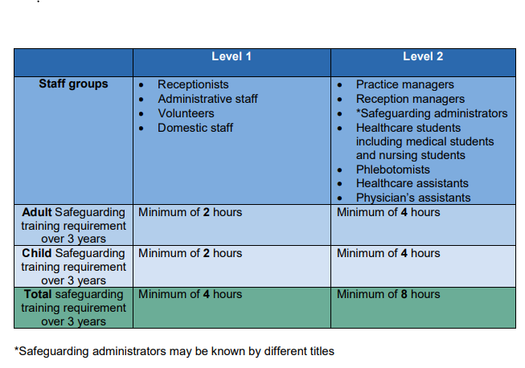

Level 3 training
- In ‘Adult Safeguarding: Roles and Competencies for Health Care Staff’, there is no distinction between different professional groups at Level 3.
- In ‘Safeguarding Children and Young People: Roles and Competencies for Healthcare Staff’, there is a distinction between professional groups who require Level 3 ‘Core’ child safeguarding training and those who require Level 3 ‘additional knowledge, skills and competencies’ child safeguarding training.

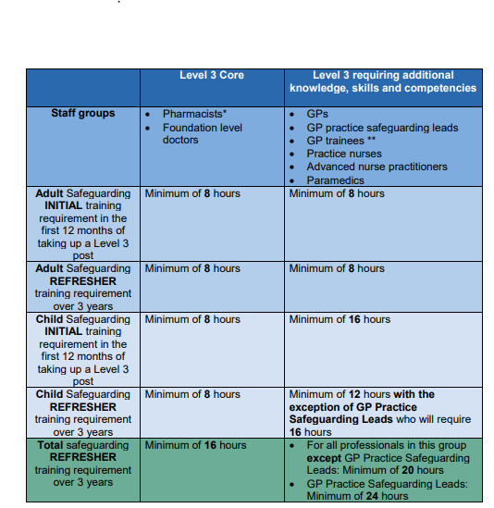

Adult safeguarding training, Level 1, 2 and 3 can be accessed via:
Safeguarding Adults - e-Learning for Healthcare (e-lfh.org.uk)

Child Safeguarding training, Level 1 & 2 can be accessed via:
Safeguarding Children and Young People - e-Learning for Healthcare (e-lfh.org.uk)
This programme must be completed before attending a face-to-face sessions run by the GP Safeguarding Children Leads.
Level-3 training can be accessed via:
- Safeguarding Childrens programme Board
- Independent course/conference (from an approved body)

How to document learning – from intercollegiate document (page 92)
- Level 1 and 2 training can be recorded in the reflection template Appendix A
- Level 3 Education, training and learning activity can be recorded on the template Appendix B
You will need to keep accurate records and document the following on an ongoing and continual basis:
- Type of education, training and learning eg, online learning, course attendance, group case discussion, independent learning
- Topic, a brief description and key points of learning activity
- The number of learning hours and the number of participatory learning hours.
Education and training at all levels should be at least 50% participatory. Participatory training involves a level of interaction. A record of training can be kept by using the Education, training and learning activity logs in the Safeguarding Children and Young People: Roles and Competencies for Healthcare Staff, Appendix 4.
Inter-professional and inter-organisational training is encouraged in order to share best practice, learn from serious incidents and to develop professional networks.
Examples of Participatory education and training:
- Attending face-to-face training
- Group case discussion
- Reflection on the learning from a case the professional has been involved in and how this learning has been applied to their practice
- Webinars
- Attendance at safeguarding forums e.g. GP Practice Safeguarding Lead forums
Examples of Non-Participatory training:
- E-learning
- Reading relevant safeguarding learning material such as guidelines or journal articles.

Appendix A
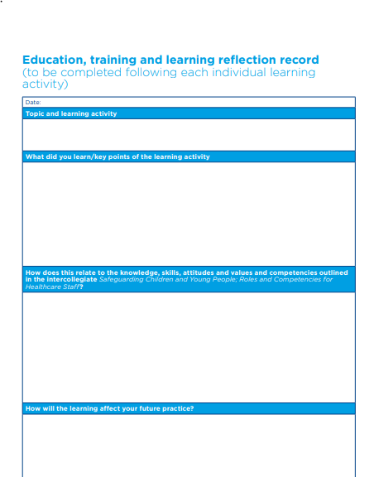

Appendix B

You will need to keep accurate records and document the following on an ongoing and continual basis:
- type of education, training and learning eg, online learning, course attendance, group case discussion, independent learning
- topic, a brief description and key points of learning activity
- the number of learning hours and the number of participatory learning hour
- E-Learning training options can be found in the grid below. The Practice Safeguarding Leads Network provides Leads with level 3 learning packages of 2 hours twice a year for dissemination in practices. Conferences and similar learning events can evidence level 3 learning.

Safeguarding Adults | http://www.e-lfh.org.uk/programmes/safeguarding-adults/  Level 1 and 2 and 3 | Bluestream academy – Level 1,2,3
Safeguarding Children | https://www.e-lfh.org.uk/programmes/safeguarding-children/  Level 1 and 2 and 3 | Bluestream academy – Level 1,2,3
 | e-lfh: NHS London region Virtual Safeguarding conference 2020 (level 4 children)
Prevent | e-lfh: Preventing radicalisation -Basic Prevent Awareness  https://www.elearning.prevent.homeoffice.gov.uk/ | LEVEL 3 WRAP Training  https://portal.e-lfh.org.uk/Component/Details/511790
Mental Capacity Act (MCA | http://www.scie.org.uk/mca/e-learning/
Deprivation of Liberty Safeguards (DoLS) | http://www.e-lfh.org.uk/programmes/deprivation-of-liberty-safeguards/
FGM | http://www.e-lfh.org.uk/programmes/female-genital-mutilation/ | https://www.fgmelearning.co.uk/
Domestic Abuse | http://www.e-lfh.org.uk/programmes/domestic-violence-and-abuse/ | Or Contact Islington Solace women’s aid s.yasmin@solacewomensaid.org
Modern Slavery | http://www.e-lfh.org.uk/programmes/modern-slavery/
Forced marriage | http://www.safeguardingchildrenea.co.uk/resources/awareness-of-forced-marriage-resource-pack/
Islington CS portal | https://www.islingtoncs.org/ for safeguarding training for Islington
NCL website | https://gps.northcentrallondonccg.nhs.uk  Safeguarding pages

safeguarding_training_requirements_for_primary_care_rcgp.pdf (gpappraisals.uk)

