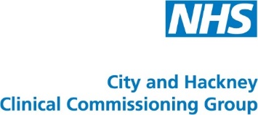

REFERRAL FORM – PRECONCEPTION CLINIC FOR DIABETES

Patient Name
DOB
NHS number
Address
Phone number

Diabetes – type 1 or type 2
Latest results:
- HbA1c
- U&Es
- Urine ACR
- BP
- BMI
Last retinal screen result
Medication list
Other PMH
Previous pregnancies? – Y/N
Previous pregnancy complications including miscarriage? – Y/N. Details
Awaiting IVF? – Y/N

Please start folic acid 5mg daily

Please send referrals to:

Email homerton.antenatal@nhs.net
Phone 0208 510 5955
Fax 0208 510 7339

Links to preconception guidelines:
http://www.cityandhackneyccg.nhs.uk/gp/pathways/

