





,

**Move4You –**  **New EMIS Search to Identify Eligible Patients for Move4You**

We have now created a new EMIS search to support you to identify eligible patients in your GP practice. **Please see the screenshot below for your borough where you can quickly find and run the required search as highlighted below** which identifies all patients who have had a Cancer diagnosis within the past 5 years

**Barnet:**

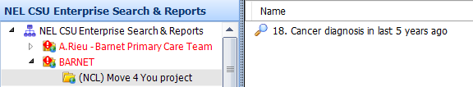

**Enfield:**

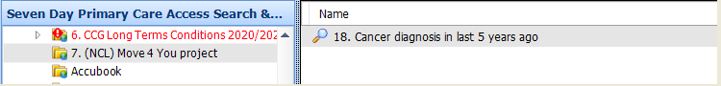

**Haringey:**

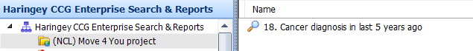

**Islington:**

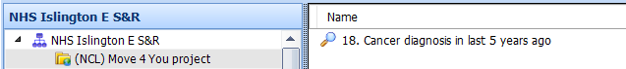

**Camden:**

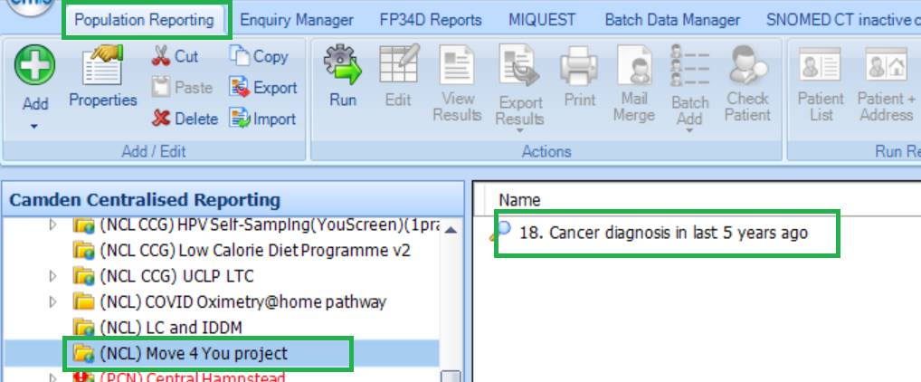

Clinician Referral forms are available on all NCL EMIS Systems OR patients can self-refer please see the attached form and leaflet. More info available here: [**Move4You GP webpage**](https://gps.northcentrallondonccg.nhs.uk/service/move4you-ncl-cancer-physical-activity-rehabilitation-service)**.**

**Contact**

If you have any questions please contact Move4You (provided by Tottenham Hotspur Foundation) on 0208 365 5138 or [Katrina.heal1@nhs.net](mailto:Katrina.heal1@nhs.net)