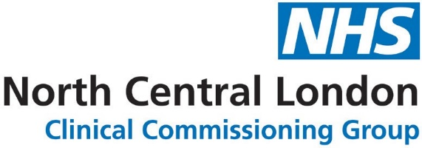

SUBMIT A SERVICE FORM
Please complete the form below with as much detail as possible and send to gp.website@nhs.net
SERVICE NAME
Please fill in

SUMMARY OF SERVICE
Please keep this succinct as a GP needs to get the gist of the service at a glance.

ELIGIBILITY CRITERIA
Inclusion: Please fill in: this can be a simple inclusion such as ‘resident of Camden’

Exclusion: Optional to fill in

SERVICE PROVIDER
Please fill in

SERVICE COMMISSIONER
Please fill in

LOGOS
Please send us a service provider and/or commissioner logo if you have them. Please ensure your files are.jpg, .png or .gif and are no larger than 10mb each. Email your files with this form to gp.website@nhs.net

WHICH NCL BOROUGH CAN USE THIS SERVICE
Please fill in (ie: Barnet, Camden, Enfield, Haringey, Islington?)

DOWNLOAD FILES
Please fill in (ie: patient leaflet, GP leaflet) Please send URL link to leaflets held on your organisation’s website, if this is not possible, please attach PDF copies when you email this form.

SERVICE FEEDBACK CONTACT DETAILS
This section is for GPs to contact the service for queries or to give feedback.
Name:
Telephone:
Email:
Website:

HOW TO REFER
Who can refer?: GPs/other health professionals (who exactly?) Provide a summary of exactly how to refer a patient to this service, ie: EMIS/e-RS with path/email/telephone etc. If patients can self-refer, state exactly how they can do so. Include any forms or links for online forms. Email your files with this form to gp.website@nhs.net

REFERRAL FORM
Please title the form with an appropriate name and email a copy with this form. (Please keep us updated if the form changes in future).

WHAT TOPICS ON THE GP WEBSITE IS THIS SERVICE RELEVANT TO
See a list of existing topics: https://gps.northcentrallondonccg.nhs.uk/topics

WHAT SERVICES ON THE GP WEBSITE IS THIS SERVICE RELEVANT TO
See a list of existing services: https://gps.northcentrallondonccg.nhs.uk/services

WHAT CLINICAL PATHWAY(S) ON THE GP WEBSITE ARE RELEVANT TO THIS SERVICE
See a list of existing pathways (or attach a new pathway to the email for us to add): https://gps.northcentrallondonccg.nhs.uk/pathways

ARE THERE ANY RELEVANT LOCALLY-COMMISSIONED SERVICES
See a list of existing LCS: https://gps.northcentrallondonccg.nhs.uk/enhanced-services

YOUR SERVICE WEBSITE
If this service has a website, please provide the URL.

SEARCH TERMS (KEYWORDS)
What keywords would GPs type to find this service. (This will help us to ensure that it appears when GPs are using the search function on the website.)

DESIGNATED REVIEWER
This is a person(s) who will be asked to review the service page annually and who would be responsible to make the web team aware of any changes that may occur within that 12-month period. Please provide name, role and email address.

CONTACT DETAILS FOR QUERIES FROM WEB TEAM
Please include your name, email address, telephone number and your role.

