Twitter | The flu jab protects you, your family and friends. You can get your free flu jab now. Find out more: https://bit.ly/359RWFE #GetYourFluJab | 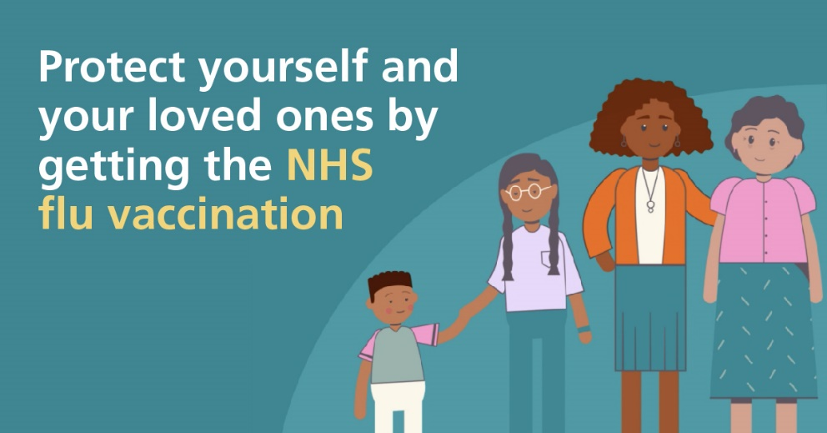
Twitter | Protect your children & those around them with a free and painless flu vaccine - it’s just a quick nasal spray! Find out more: https://bit.ly/359RWFE #GetYourFluJab | 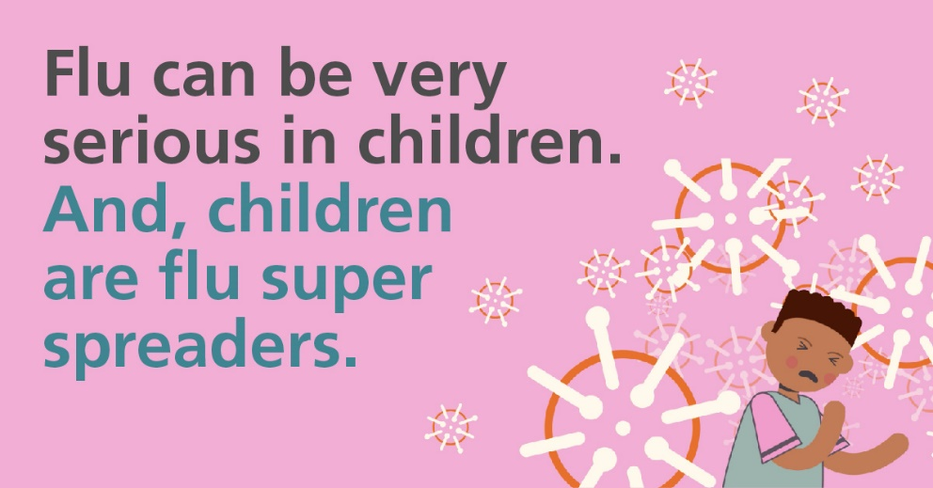
Twitter | Due to coronavirus, it is doubly important that you get your flu jab. Protect yourself as well as those around you by getting yours today. Find out more: https://bit.ly/359RWFE #GetYourFluJab | 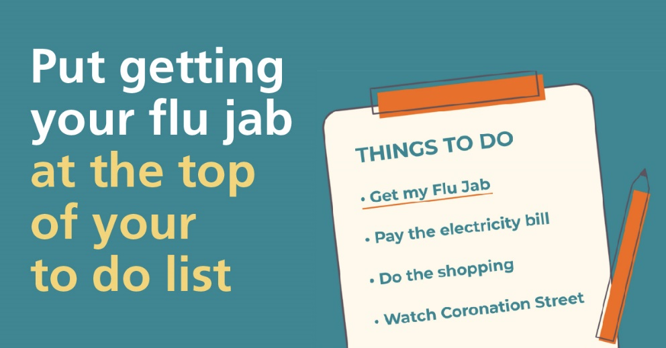
Twitter | Protect yourselves and others from the flu virus – get the flu vaccine now. You can find out more here: https://bit.ly/359RWFE #GetYourFluJab | 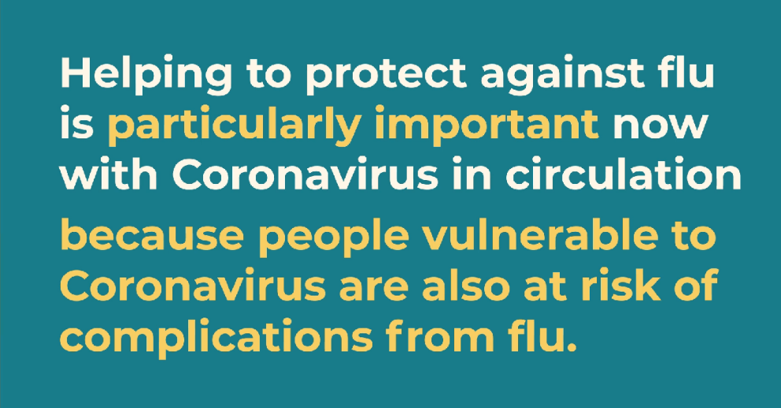
Twitter | If your child was aged 2 or 3 on the 31 August, protect them & those around them by ensuring that they get their free, safe and painless flu vaccine. It’s just a quick nasal spray- no needles. Find out more: https://bit.ly/359RWFE #GetYourFluJab | 