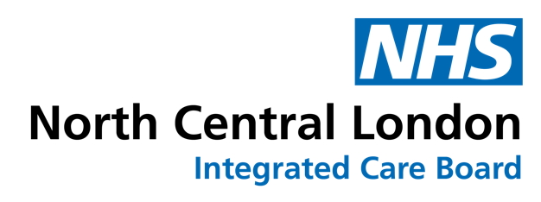
How to get a referral form into EMIS and onto the NCL GP Website

Please note: Barnet/Enfield/Haringey and Islington use NEL CSU to manage EMIS documents. Camden has a different internal process. Further information on this is given below.

Provider sends web team a referral form to add/update

If a referral form comes in from a provider, the web team forwards the email/form to the commissioner of the service to advise them of the new form. The commissioner initiates the process described below.

Commissioner has a referral form to add/update

For forms relevant in one or more of the five NCL CCG boroughs

Commissioner sends referral form to NEL CSU, pauline.trecherel@nhs.net AND richard.anthoney@nhs.net for conversion to EMIS form, and copies in NCL GP Website team, nclicb.gp.website@nhs.net, specifying
    - the relevant NCL boroughs (Barnet/Camden/Enfield/Haringey/Islington) to use the form
    - the exact website content (URL of service pages etc) that will be affected by the change
- CSU gives commissioner AND web team a rollout date/file name/file location (for B/E/H/I)
- CSU also sends EMIS-compatible version of the form as a zipped file to the Camden IT & Systems team nclicb.itandsystems@nhs.net and copies in nclicb.gp.website@nhs.net to initiate the Camden EMIS forms process (see 2nd/3rd bullet in ‘For Camden-only forms’, below).

For Camden-only forms

- Commissioner emails the word version of form directly to the Camden IT & Systems team nclicb.itandsystems@nhs.net and copies in nclicb.gp.website@nhs.net asking for it to be converted to EMIS.
- Once the form is converted, it will get tested by a clinical person
  - the requester will be asked by the IT & Systems team if they have a clinical person who can test it
  - if not, they will get Ehsan Alkizwini (Digital Transformation Clinical Lead: Camden) to test it
- The zipped .ewdt file (EMIS file) will then be sent to the web team nclicb.gp.website@nhs.net to be uploaded onto the Camden EMIS Forms page and signposted from relevant service page(s).

For all forms: Next steps

- On receipt of the roll-out details from NEL CSU, the web team updates all relevant service pages on the GP website and the Camden EMIS forms page and lets the commissioner who sent the form know it is done.
- CSU informs practices of the week’s EMIS roll-outs
  - for Islington practices, by sending the web team a weekly news item on EMIS roll-out for Islington GPs only (deadline 5pm Monday)
  - for to B/E/H practices, the CSU directly emails the list of EMIS roll-outs to practices
- The web team publishes Islington EMIS forms news item and adds it in the NCL GP Weekly Bulletin/lets CSU know this is done.
- If required, the commissioner sends in a completed News Item template form about this Service Update for NCL GP Website/ NCL GP Weekly Bulletin, web team publishes and lets commissioner know this is done.

