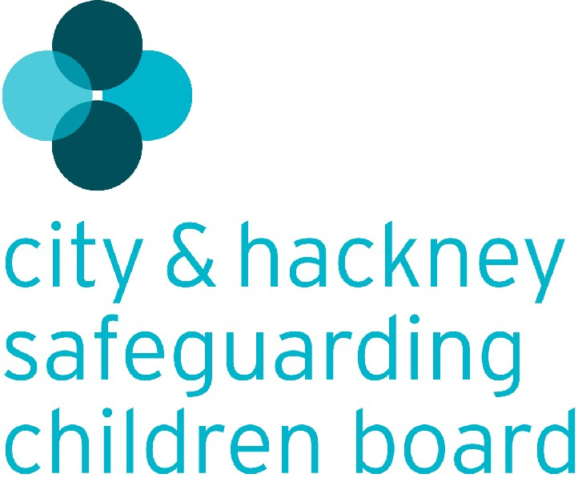
Agency referral to Hackney Children’s Social Care
Referral form for use by all agencies.

PLEASE NOTE THAT A WRITTEN REFERRAL FORM IS REQUIRED IN ALL CASES.
WHERE A TELEPHONE REFERRAL HAS BEEN MADE BECAUSE OF THE URGENCY OF A SITUATION THIS MUST BE FOLLOWED UP WITHIN 48 HOURS BY A COMPLETED REFERRAL FORM UNLESS AGREED OTHERWISE.

Name and contact details of person making the referral
Name:
Name of agency/organisation:
Address:
Telephone Number: |  |  |  |  | Fax Number:
Email Address:
Date written referral is being made:
Date telephone referral made (if applicable) and to whom:
Relationship of person making the referral to the child/family:

NAME(S) and DATE(S) OF BIRTH of the child(ren) being referred (please list here all children in the family):
Child(ren)’s preferred language if not English speaking:
Ethnic origin and Nationality if known:
Details of wider social and professional network (e.g. significant family / friends, GP, health visitor, schools, professionals working with members of the household)
Name | Role/  Relationship |  | Address |  |  |  | Telephone  number | Email
Name of parent(s)/carer(s) with whom child(ren) live(s):
Parent(s)/Carer(s) preferred language if not English speaking:
Address:
Telephone number(s):
Any other relevant family details:

Why is a referral being made? What are the concerns? (Please be as specific as possible, giving dates, examples of incidents etc):
Is the referral for information only?
Is there evidence that any children in the family are being subject to significant harm?
If ‘YES’ please specify:
Actions taken by referring agency/involvement with the family:
Please outline your involvement with the child/family and any ongoing support that is being provided. Detail any past concerns or known involvement of statutory agencies. If a CAF or other assessment document has been completed please attach a copy to this referral.
What outcomes are anticipated by the referral?
Does the person with parental responsibility know that a referral to Children’s Social Care has been made?
If ‘No’ please explain why:
If yes, does the person with parental responsibility consent for members of the family’s network to be contacted to obtain further information?
Any other information that would be helpful in deciding the priority of the referral and/or understanding the actions Children’s Social Care is being asked to take in respect of the child(ren) being referred?
Please e-mail this form to FAST@hackney.gov.uk for the attention of the Referral Manager. If you need to send it to a CJSM email address please send to fast.account@hackney.cjsm.net .

If you have difficulties sending this by email please fax it to 020 8356 5516/7.

Should you need any assistance in completing this form or wish to follow up your referral please call the First Response Service on 020 8356 5500.
If your referral has not been acknowledged by Children’s Social Care within three working days please make contact to confirm it has been received.
Please ensure that you have sent a copy of this referral to the safeguarding children lead for your agency.

