**City & Hackney**

**NHS Wi-Fi Support Information**

**The NHS Wi-Fi in City & Hackney is supported by Egton. Both patient and the practice can request help for any issue relating to the Wi-Fi using the information below**

**Tel: 0845 125 5530**

**You would need to provide your practice CDB number and ODS code**

**(Help desk hours – 8:30-21:00, 7 days a week, excluding December 25th -26th and January 1st)**

**Please note that the NHS Wi-Fi- Public is free and registration will be done by patients once they connect to the service**

**Useful Links for Practice use Only**

1. **Your Wi-Fi network –**

[**http://support.egton.net/support-centre/your-wifi-networks/**](http://support.egton.net/support-centre/your-wifi-networks/)

1. **How to request Wi-Fi accounts for Practice staff and NHS Guest that requires access to the N3**

[**https://form.egton.net/machform/view.php?id=275580**](https://form.egton.net/machform/view.php?id=275580)

**The form should be completed using the following information**

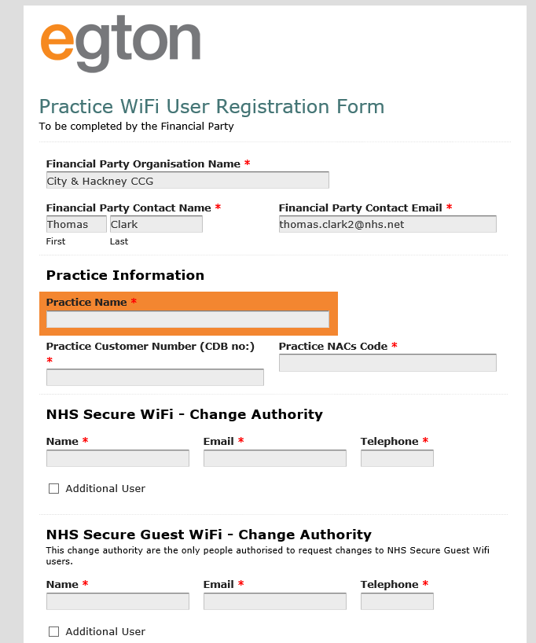

**You will then need to download and complete the user registration spreadsheet**

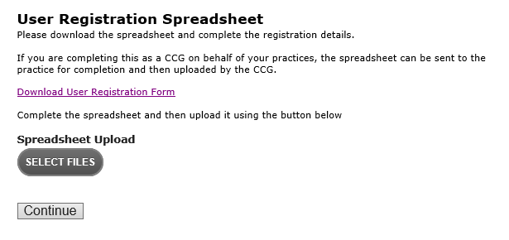



**\*\*\* Please ensure that you upload the completed spreadsheet with this form**

**See example below**

