UCLH EMIS tQuest Systems

tQuest is a GP order comms system linked through EMIS web and is configured with the UCLH catalogue. Pathology orders made through tQuest are sent electronically to the lab; this reduces manual data entry errors and improves patient safety. Radiology orders cannot currently be requested through the UCLH tQuest system.

Review is a results look-up system linked to tQuest and allows GPs to view patients’ results from GP and hospital visits.

If you require any help with accessing either systems, please contact your relevant GP IT in the first instant. You can also contact the laboratory IT Helpdesk using helpdesk@tdlpathology.com and state which GP practice you are calling from and who is logged into EMIS web.

Requesting Tests

Within EMISweb, select the patient that you wish to make the request for, click Add, select Test Request from the left pane menu, then select Online Test Request.

If the GP practice is linked to more than one tQuest provider, select the relevant provider by clicking on the name.

This will bring up the tQuest screen where you can place a new pathology orders or view previous results.

To order new pathology requests, select the required tests and click on 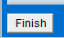 to print out the request form.

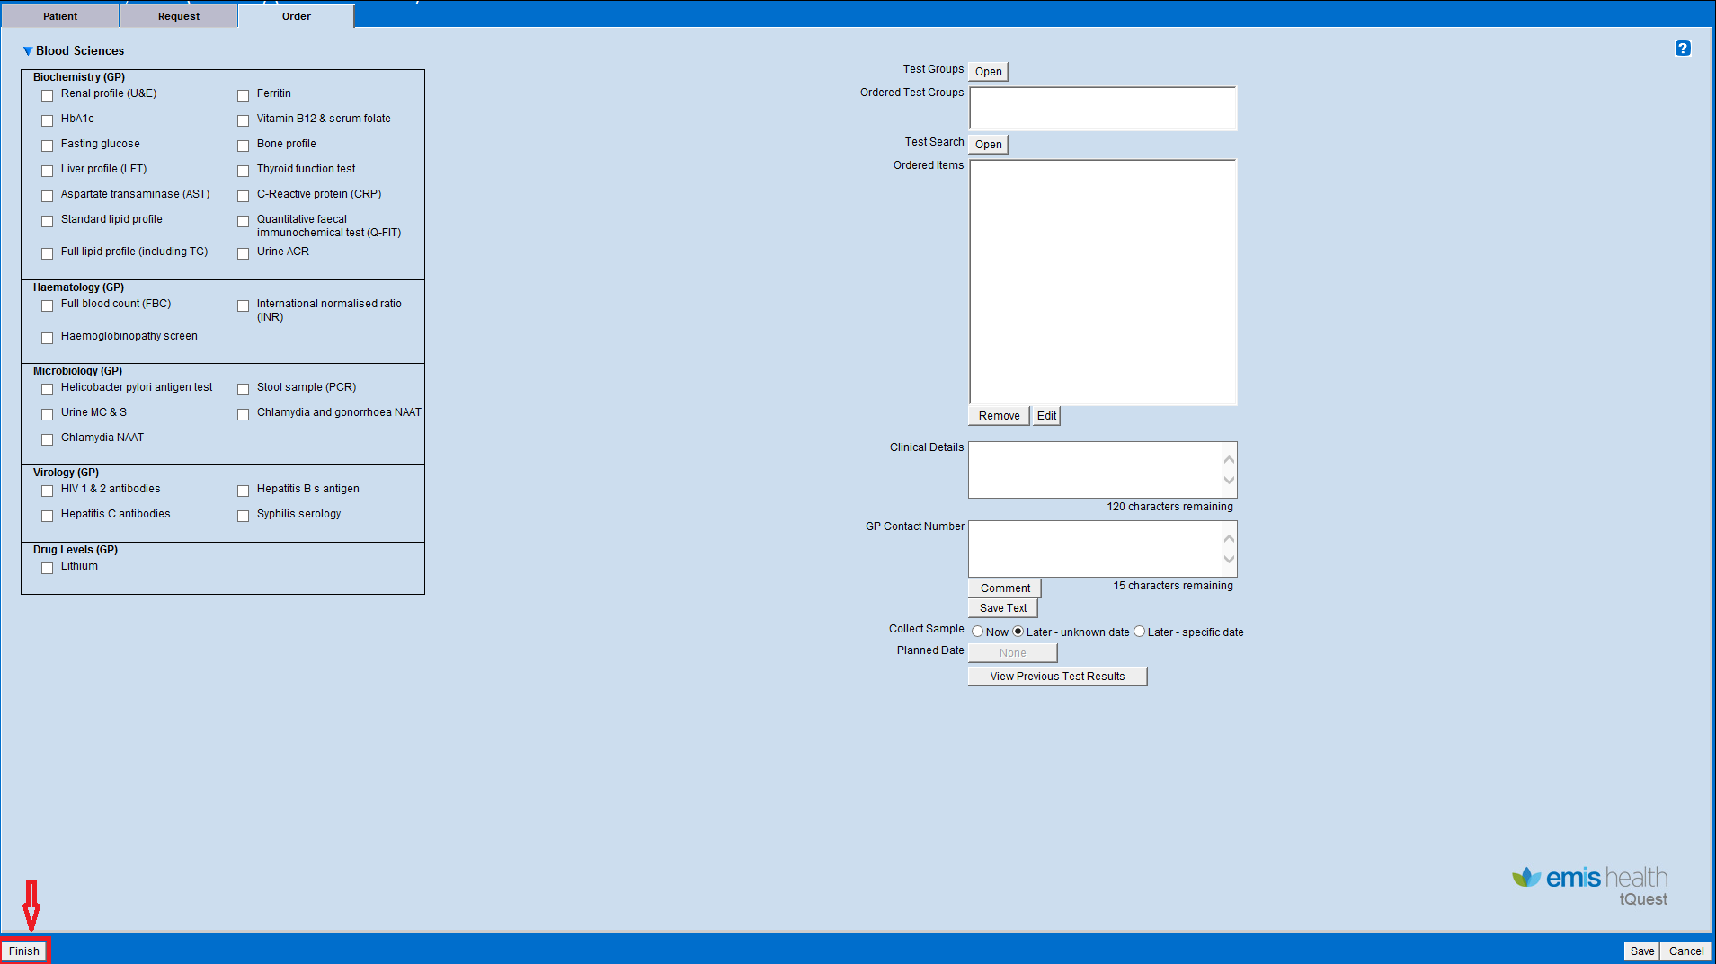

Test Groups
You can use the test group function to request a group of tests linked to a certain suspected diagnosis. NB: use the “Approved NCL GP Order sets”.

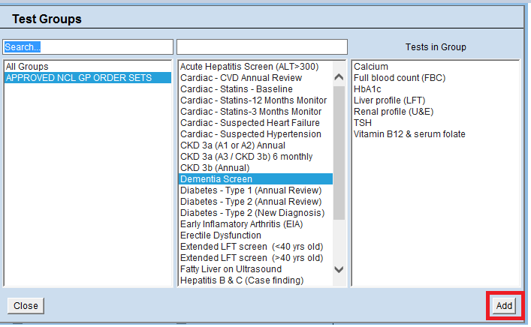
You can add or remove more tests from the tests in the test group.

Test Search
You can use the Test Search function to search for tests not displayed on the home page. Type all or parts of the name of the test in the search box.
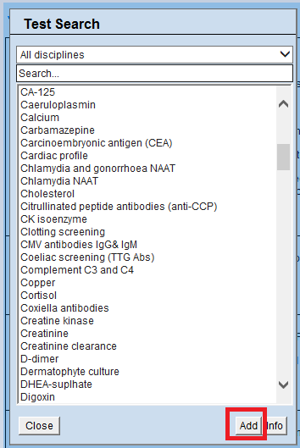

Once you click on the button at the bottom left-hand corner of the page, you will be promoted with a message to confirm if the selection is correct.
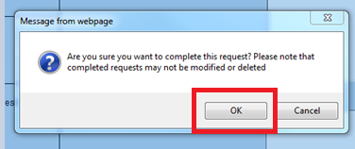

The next step is to select the printer you wish to print from. After doing this, click on Save & Print. If the print comes out mis-aligned, you can adjust the settings and re-print the request form.
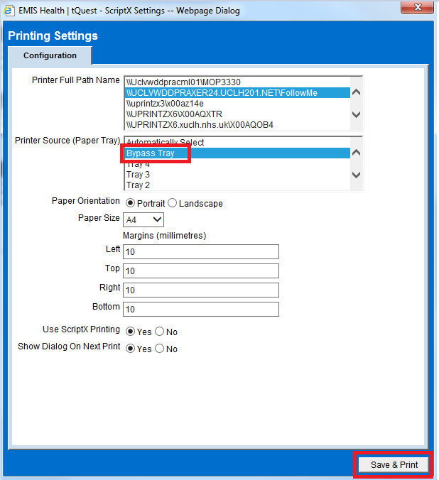

Viewing previous pathology results through tQuest
To view the a patient’s previous results from UCLH, click on the button “View Previous Test Results”
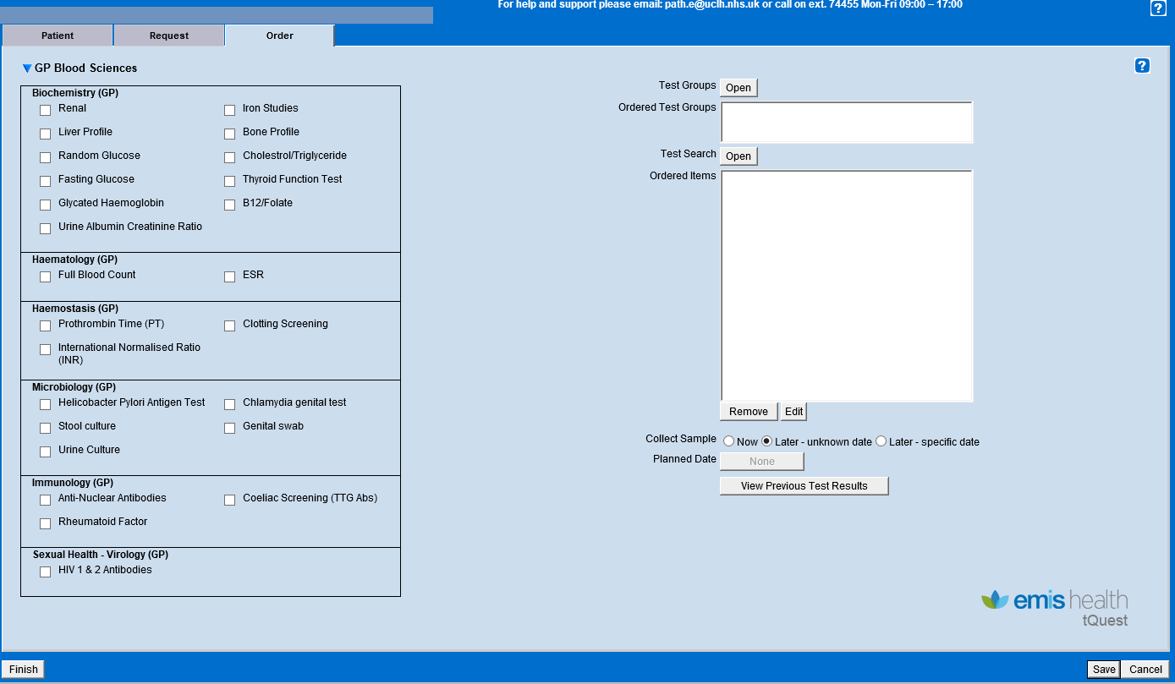

This will bring up all previous requests (GP and UCLH) with the patient’s NHS
Number (only if previous results are available). To view results, select the relevant
episode and click view.

The results for this episode will be displayed.

Help

- To contact Pathology at UCLH, please ring 0203 447 4455 or email uclh.enquiry.path.e@nhs.netclh.enquiry.path.e@nhs.net

- To order printing material (A5 sticky paper), please email the address uclh.enquiry.path.e@nhs.net, stating which GP practice you are requesting on behalf, and who the delivery should be addressed to. Receipt of printing paper may take up to 5 working days from request date.

- If you require any help with ordering tests/viewing results, please contact the relevant GP IT service desk.

