E-Referral Service – Using Advice & Guidance

Contents
Page 1 – Introduction/User Prerequisites
Pages 2-8 – Making an Advice & Guidance Request in EMIS Web
Page 9-11 – Managing Advice & Guidance Requests
Page 11 - Escalations
Introduction
This reference guide can be used in order to process an Advice & Guidance (A&G) Request using the NHS e-Referral Service (e-RS) within EMIS Web (in the perspective of a GP). An A&G Request allows a GP to seek advice from a provider consultant.
The reasons why a clinician may wish to seek Advice and Guidance include:
• Asking another clinician/specialist for their advice on a treatment plan and/or the ongoing management of a patient.
• Asking for clarification (or advice) regarding a patient’s test results.
• Seeking advice on the appropriateness of a referral for their patient (e.g. whether to refer, or what the most appropriate alternative care pathway might be).
• Identifying the most clinically appropriate service to refer a patient into (and how to find that service – e.g. what clinical term to search on).

Further benefits are documented in the link below:
http://content.digital.nhs.uk/media/17307/Advice-and-Guidance-overview/pdf/Advice_and_Guidance_Overview_-_February_2017.pdf
User prerequisites prior to using e-RS

- Ensure you are logged in to EMIS Web with your smartcard

- Ensure the PDS is up to date in EMIS Web (Blue PDS icon)

- The patient selected is correctly registered on the NHS Spine.

- All clinicians who need to use e-RS, or used on their behalf, are configured as service people in Organisation Configuration. Please see link for further details -

Making an Advice & Guidance request in EMIS Web
1 - To initiate an Advice & Guidance Request, open a patient’s care record in the Consultation or Referral tab.
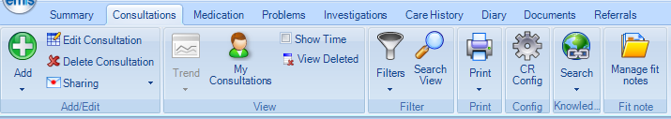
Click on the Add and select Referral, NHS e-Referral and then select a Routine as the Priority.
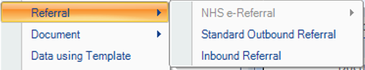
Routine
Urgent
2 Week Rule
2 - e-RS will then launch the screen below within EMIS Web, prepopulating the patient’s demographic details in the process. As you entered Routine as a priority in EMIS Web this also prepopulates. However, you will need to change the Request Type to Advice. Please note that where a * is present an entry must be made in order to continue to the next screen.

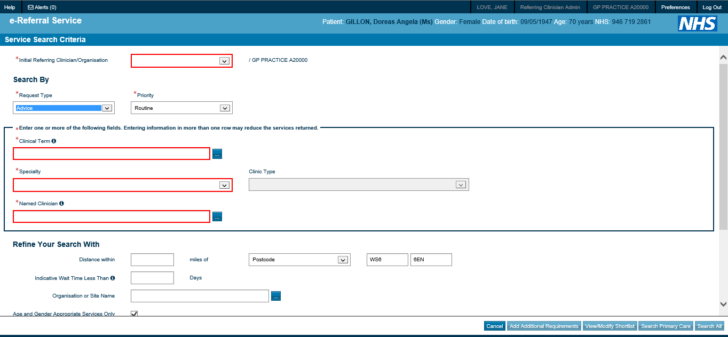

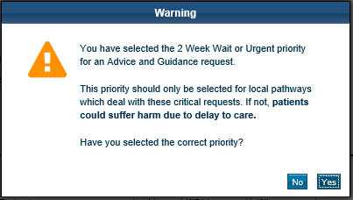
Please Note that Advice and Guidance Requests should only be made under a Routine Priority. Any other Priority chosen will produce this warning message.

3 – From the drop down menus below choose a Specialty AND Clinic Type. Alternatively you can search via Clinical Term or Named Clinician (click on )

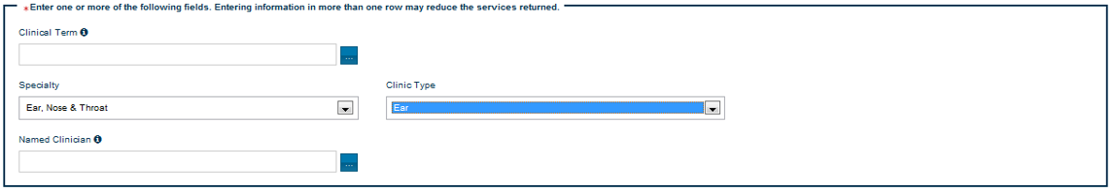

4 – Click in the bottom right corner of your screen to produce a list of services based on your search criteria.

Please Note Only those services meeting your search criteria AND that have agreed to respond to Advice and Guidance requests are displayed.

5 – Select a Service Name by clicking its radio button to the left of the Service Name (you can only select one service).

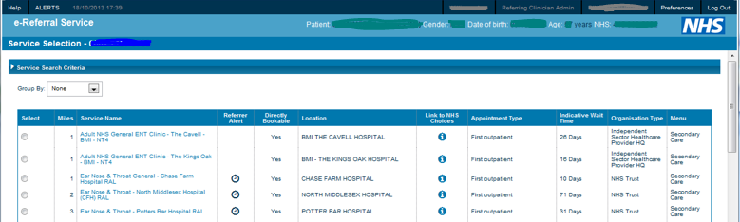

6 – Once you have decided on a service, click in the bottom right-hand corner of your screen (button will be greyed out if no service is selected).
7 – You will then see the Criteria Overview Screen which gives brief information when on what the service offers and exclusion details. Either click (i.e. to screen above) or to carry on.

8 - Enter your Request into the red box below. This is the only mandatory entry.

Please note that the right click function on your mouse does not function when using e-RS. If you need to paste text, hold down the CTRL button and press V to paste into the red box.

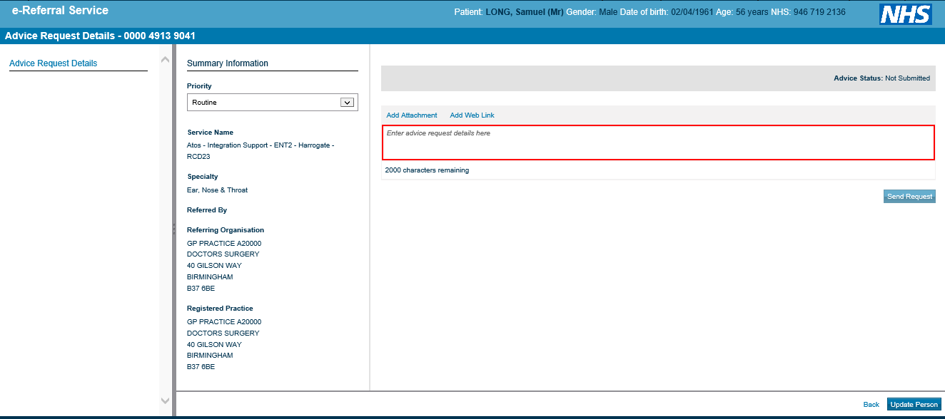

Please Note Do not add attachments using the Add Attachment button. We can add documents and clinical information from EMIS Web later using an integrated process.

Please note: Any attachment added must NOT be a referral letter as you are requesting for advice and guidance only.

10 – Click on the right-hand side of your screen to submit the request (this button is greyed out if you do not enter anything into the red box). Confirmation will be confirmed as below which gives the option to Print (or save as a PDF using this option) if you wish to add to the patient’s care record in EMIS. Otherwise click OK to continue.

11 – Once the request is submitted, click on the Please Select an Option menu button on the bottom right-hand side of your screen and select I have selected a service and click OK.

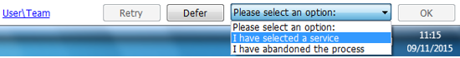

12 – Click Yes below to continue.
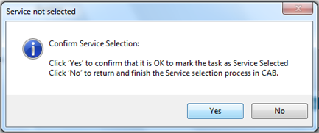

13 – Complete the window below where you find a red asterisk *. In fact apart from a Clinical Term (type Advice to find the code needed) the other fields are complete. This information is added to the care record in EMIS Web.
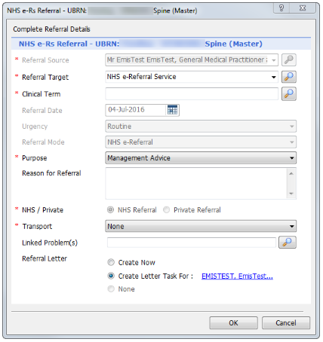
14 - Then either choose: -- Create Now (i.e. add clinical content from EMIS) or
- Create Letter Task For (to assign to other staff to add clinical content later).
Then click OK.

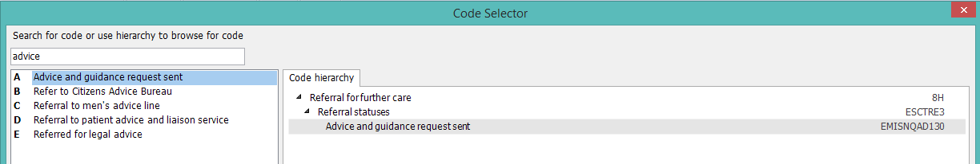

15 – Which ever option selected above, it will allow you to add further content directly from the patient’s care record using the screen below.
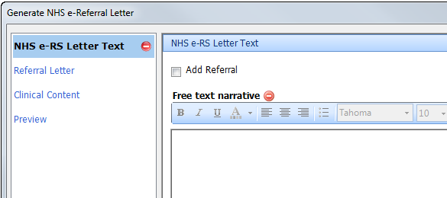
For NHS e-RS Letter Text you must either:
- write something in the Free Text Narrative pane (e.g. see attached request) or
- click on the Add Referral tick box and then select Referral Letter to choose a letter template (remember you cannot add a referral letter as you are requesting Advice and Guidance but you could add a practice letter for example).

16 – Click on the Clinical Content tab to show entries from the patient’s care record and select anything relevant to support your Advice request. You can also add saved practice letters in the care record using the Attachments option. EMIS by default will create and send a medical summary document containing current problems, meds and allergies.
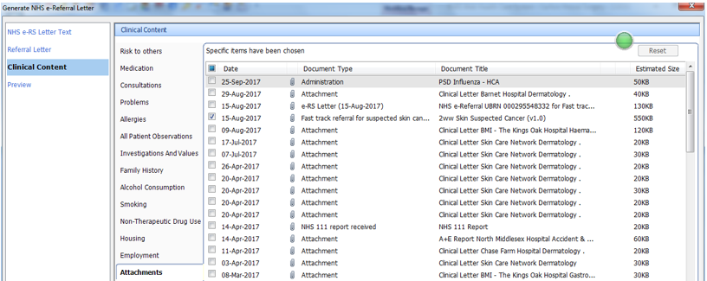

17 – Click on Authorise and Send at the bottom of your screen to attach the selections above to the e-RS Advice and Guidance request. The A&G Request is now completed and a Unique Booking Request Number (UBRN) is created in e-RS and an entry is made in the Referrals tab of the patient’s care record.

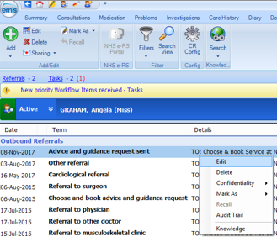
18 – To edit the clinical information in an Advice & Guidance request:

- find the A&G request entry in the Referral tab

- right click to Edit

- follow steps 13-17 above.

EMIS Web supports attachments in the following file formats (however please be warned the provider service may not be able to open some file formats due to their IT infrastructure):
- Text files: plain text (.txt), HTML, PDF, XML, rich text (.rtf), Microsoft Word (.doc, .docx)
- Docman files (if they don’t attach, select Check Out for Editing to save as a TIF document outside of Docman)
- Audio files: basic, MP3, MPEG
- Image files: PNG, GIF, JPEG, JPE, JPG, TIFF, TIF
- Video files: MPG, MPEG
When you add attachments to the NHS e-referral service, warning messages are displayed if any of the following applies:
- The total attachments selected exceed 5MB (or 5000Kb)
- You select an invalid file extension.
- There is an invalid character in the filename.

Managing Advice and Guidance Responses
Currently there is no facility in e-RS that informs you by email that you have a response to an Advice and Guidance request. However this is functionality that will be available in the future. Therefore you will need to monitor the Worklists screen in e-RS if you are expecting a response from a service provider. Responses should be within 3 working days.

1 – To access e-RS from within EMIS click on the Referrals tab and select the NHS e-RS Portal button on the ribbon. Or the EMIS button/bubble has a link to it in External Links. Alternatively you may have a Choose & Book/e-RS icon on your desktop.

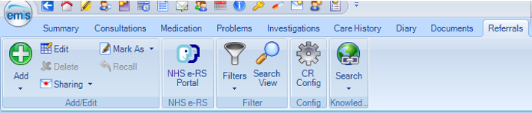

2 – Once e-RS has launched and you have selected a Role (choose Referring Clinician Admin/Referring Clinician) and click OK.
3 – Once e-RS has launched, select the Worklists tab, click on the Advice and Guidance from the Worklist Type menu.
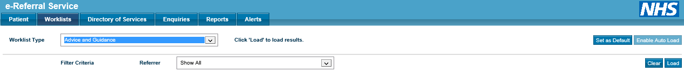

Please note that a worklist will be empty every time you access it so you must click the Load button to refresh the list.

4 – Once the list has been loaded with results, you will find outgoing request and incoming responses.
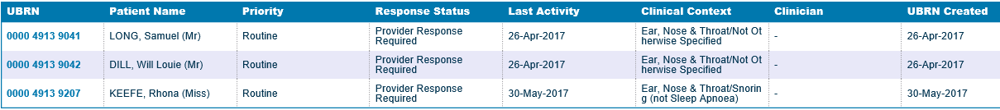
  - Provider Response Required – The provider has yet to respond to your request.
  - Referrer To Review Response – you must review the response given for further actions
  - Referrer To Submit Further Information – the provider needs more information from you in order to give an appropriate response.
5 – Click on the blue UBRN to view the response to your request from the provider clinician below. This is called the Advice Conversation. The response can also include attached documents.
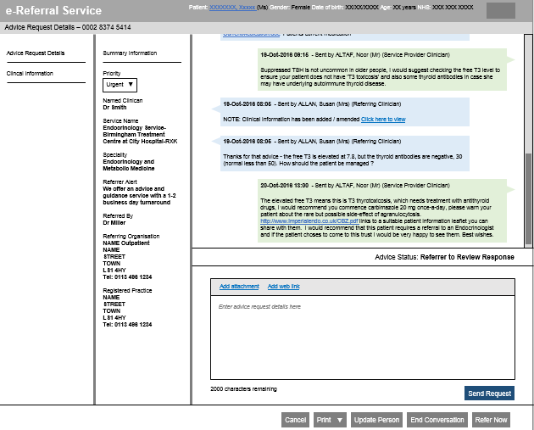
If you need to copy the Advice Conversation into the patient’s care record, either:
- Highlight the text needed, the copy (Ctrl+C) and paste (Ctrl+V) into a consultation as a comment.
- Click on the Print button on the Advice Conversation screen (page 10). A PDF version of the Advice will open. Click on the Save icon at the bottom of the screen. Save to your PC (e.g. desktop). You can then attach the PDF into EMIS.

6 – Depending on the response you receive the actions you can take are either:

- Send Request – i.e. follow up the response with further questions, queries or give more information if it has been requested.
- End Conversation – if no further advice is
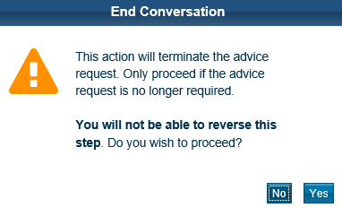
needed chose this option to remove the
UBRN from the Worklist. The warning message on the right will appear when choosing this option.

- Refer Now – If the provider has suggested a referral is suitable then choose this option. You will be taken to the Search Service Criteria screen (below) to follow the steps to refer the patient. Once complete the patient’s referral will move to the Awaiting Booking/Acceptance worklist. All advice and guidance received will be automatically attached to the referral i.e. any attachments and the Advice Conversation.

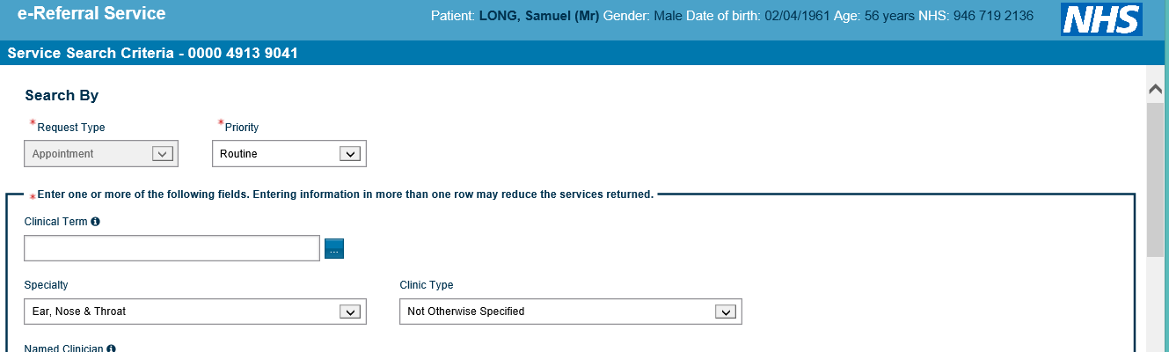
Please Note DO NOT use Advice & Guidance requests in relation to Two Week Waits or Urgents. Please use your usual pathways.
Please Note all patients shown in this document are fictitious.
Escalations
For reporting errors or faults please email nhs.ers@nhs.net . Please include screen shots of the problem and your practice name and ODS/NACS code e.g. E81234
If e-RS not launching/opening please log a call with GP Service Desk on 020 3688 1414 (nelcsu.gpservicedesk@nhs.net)
For training advice please log a call with GP Service Desk as above
For issues with providers, please contact denise.pettit1@nhs.net

