Easy Read PCN Hub template letter - Learning Disability

Your NHS Number: XXXXX
Date: XXXXXX

Address 1
Address 2
Address 3
Address 4
Postcode

Book your coronavirus (COVID-19) vaccine appointments now

Dear [XXXX]
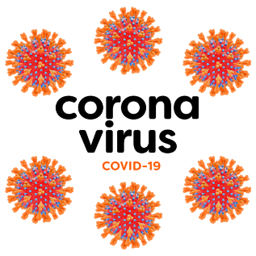 | This is an important letter about coronavirus.
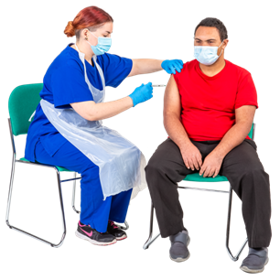 | You can now book an appointment to get a coronavirus vaccine.
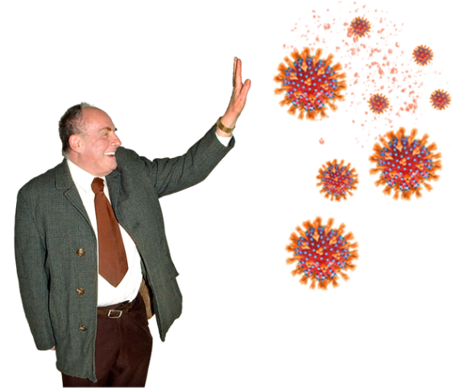 | The coronavirus vaccine will help protect you against coronavirus.
 | You should book your coronavirus vaccine as soon as possible to help keep you safe and well.
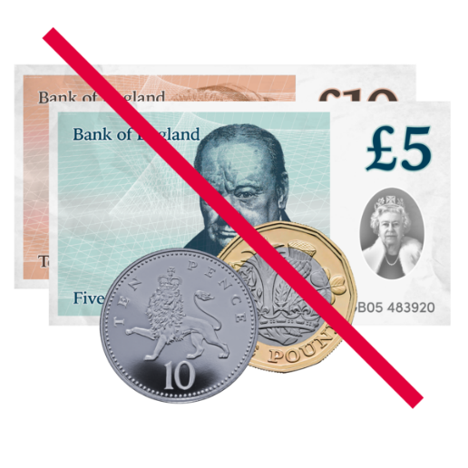 | Getting the coronavirus vaccine is free.
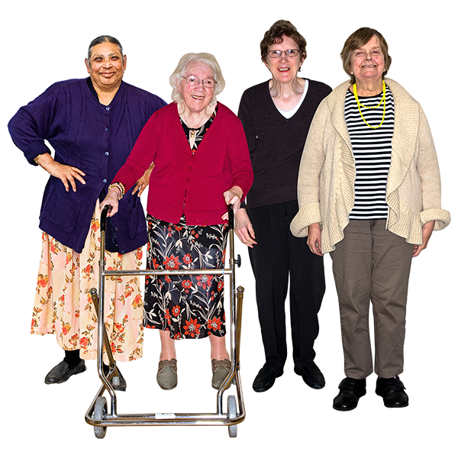 | Why you should get a coronavirus vaccine  It’s really important to get the coronavirus vaccine.  This is because the coronavirus is more dangerous for people with a learning disability
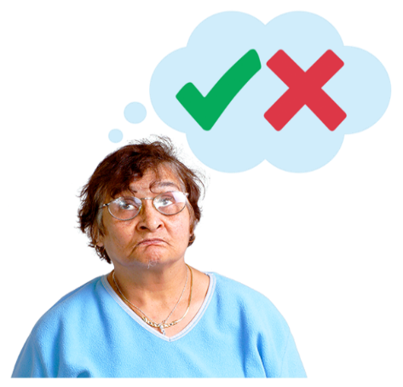 | It’s your choice to get the vaccine, but you can ask someone to help you decide – this might be your support worker or someone else you trust.
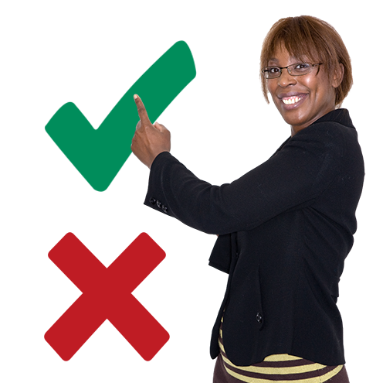 | Sometimes, if you can’t decide yourself, someone else will decide for you to keep you safe. This is called a best interests decision.
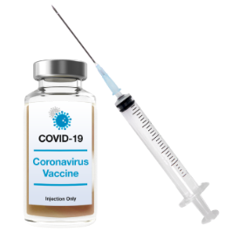  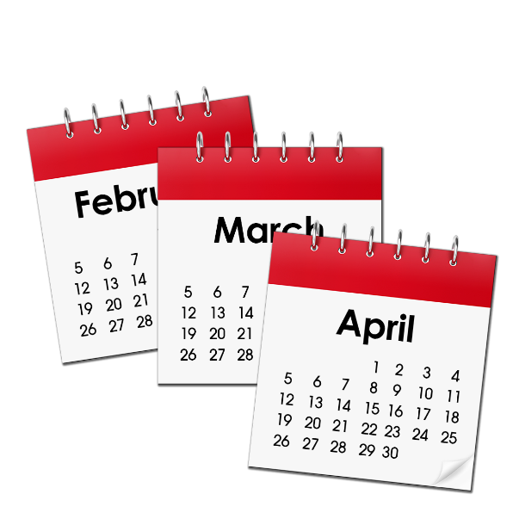  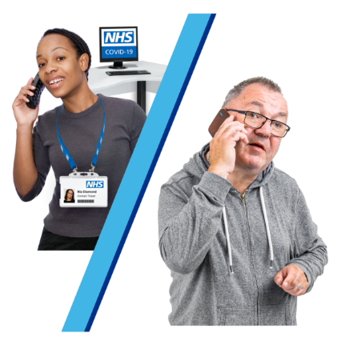  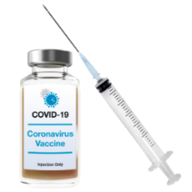  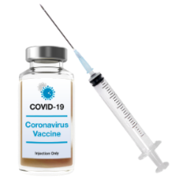 | How to get the coronavirus vaccine  You will need 2 injections of the vaccine.  Your second injection of the vaccine will be up to 12 weeks after your first injection of the vaccine.  You’ll either book your second vaccine when you book your first one, or the person on the phone will make a plan with you for how to book your second appointment.
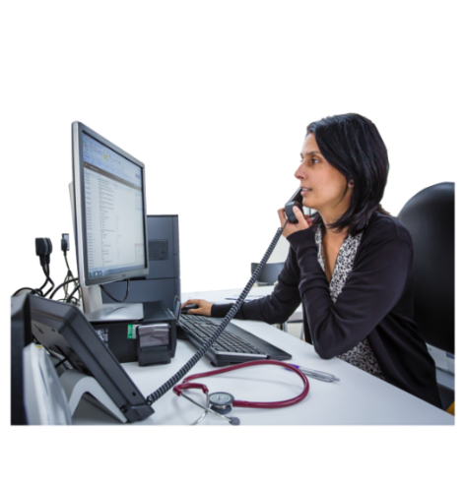

You can book your coronavirus vaccine through your local primary care hub.

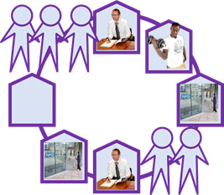

Primary care hubs are places where you can get the coronavirus vaccine that are run by your local GP services.

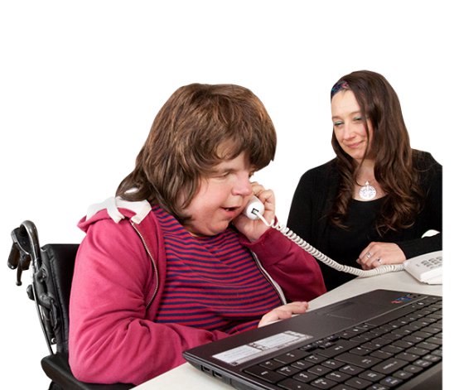 | You can ring to book your vaccine on XXXX.  You can ask someone to support you to ring up, or someone else can ring up for you.
The person on the phone will ask you –

- Your name and date of birth

- Your NHS number
[INSERT]

Make sure you have this information ready to tell them.

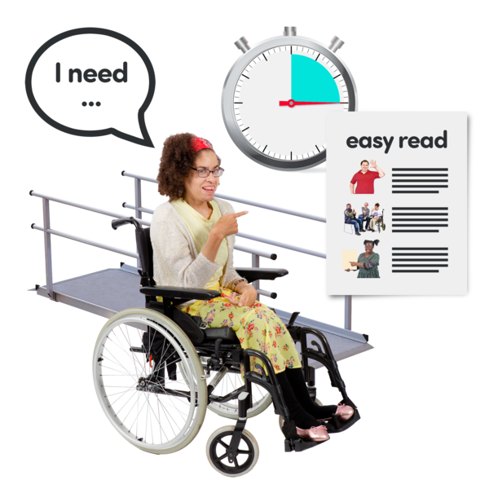 | You should tell the person on the phone that you have a learning disability.  You can get reasonable adjustments like –  - A longer appointment  - Somewhere quiet to sit whilst you wait for your appointment
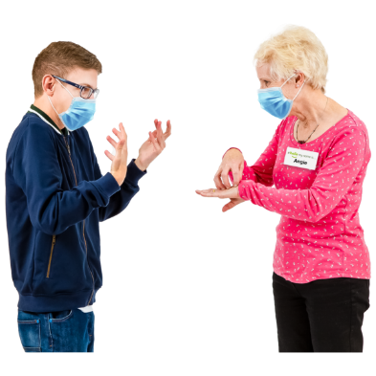  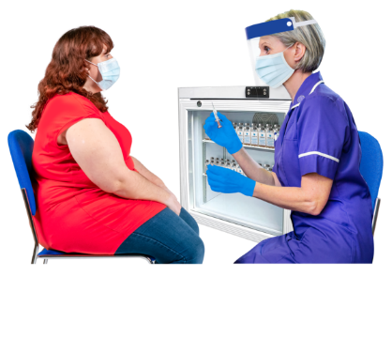 | - Support if you are scared of needles  - Sign language service.
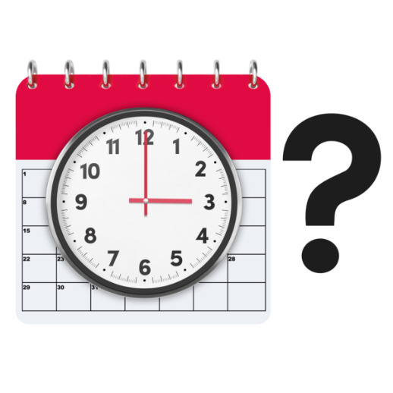  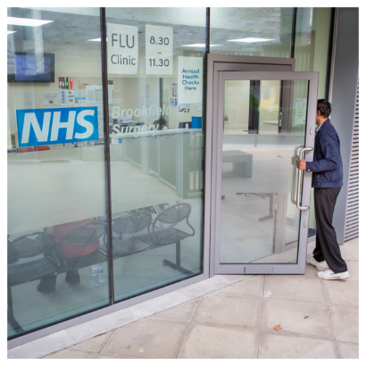 | The person on the phone will tell you –  - where your appointments will be  - the times of your appointments
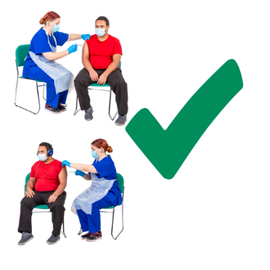 | If you’ve already had your first injection when you get this letter, the NHS will contact you when it’s time for your second injection.  It is important that you get both injections of the vaccine to make sure you are fully protected from coronavirus.
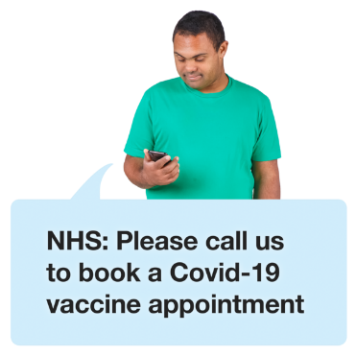 | If you can’t easily leave home to get to your appointment, or if you think you will struggle to get to the primary care hub, tell the person on the phone and they will talk to you about making different arrangements.
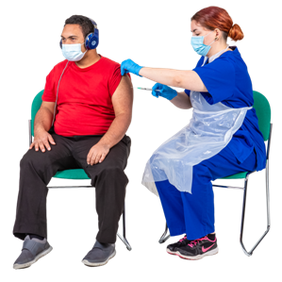  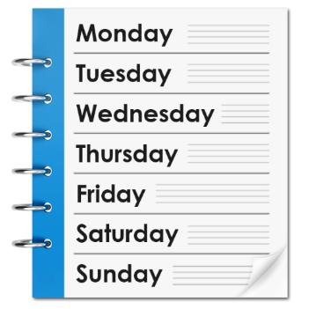 | Flu  If you have just had your flu vaccination (jab), you’ll need to wait 7 days (1 week) until you get your first injection of the coronavirus vaccine.
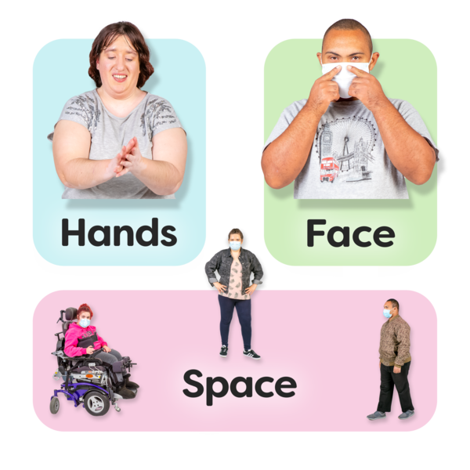 | Keeping you safe  There are lots of things in place to keep you safe at your appointments, like social distancing and everyone wearing face masks.
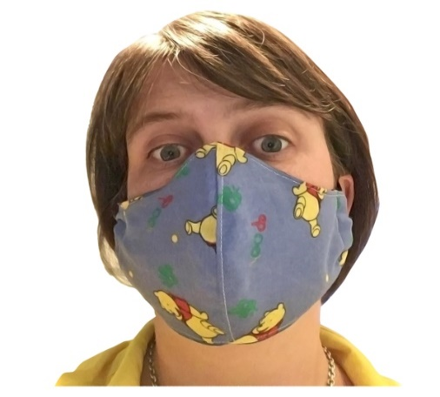 | You should also wear a face mask if you can.
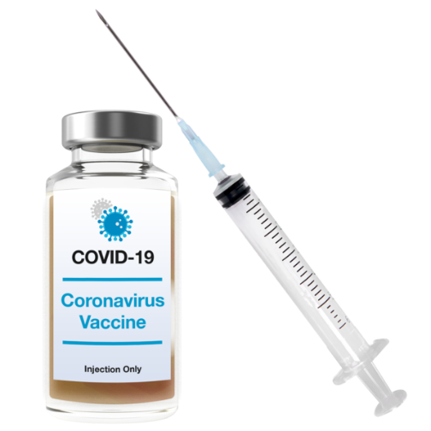 | The coronavirus vaccine has been tested lots so we know it is safe and works well.
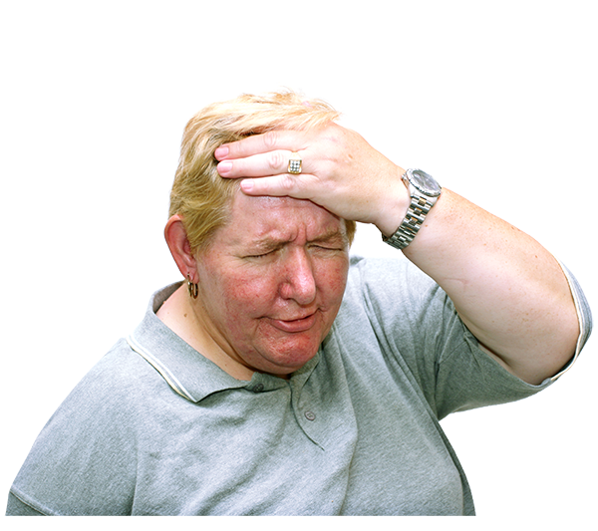 | You might feel a little bit poorly for a short time after you have the vaccine. This is called having side effects.
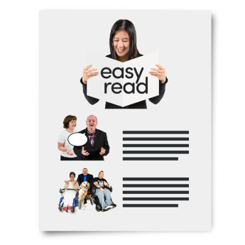 | You can read more about the side effects that you might get in the leaflet that came with this letter.
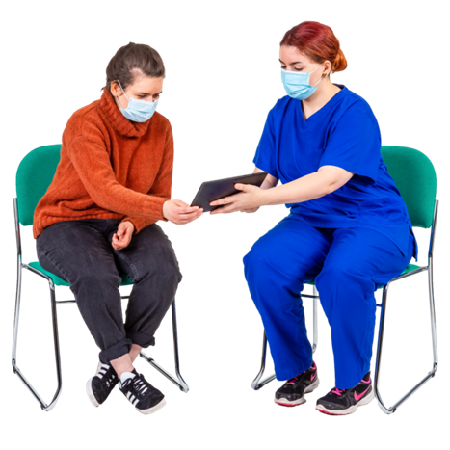 | You can also ask the person who gives you your vaccine about side effects.
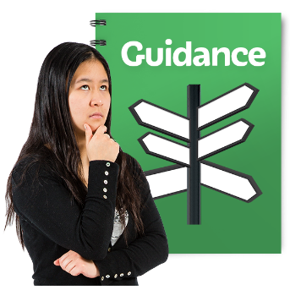  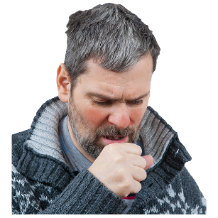  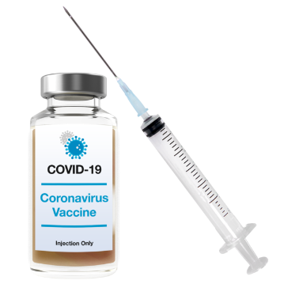 | Some people can’t get the coronavirus vaccine at the moment.  This might include you, if you have had bad allergic reactions before.  It is important that you read all the information in the leaflet with this letter.

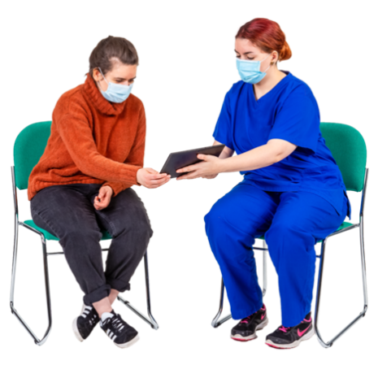 | You can also ask any questions when you book, or talk to the health professional when you go to your appointment.
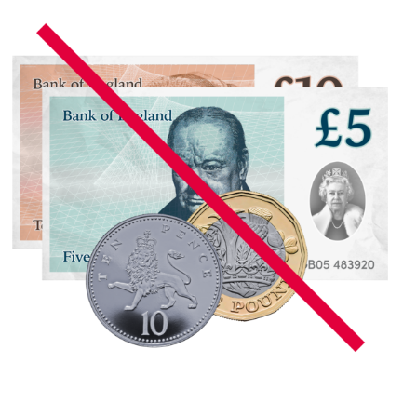 | Remember –  - you can only get the coronavirus vaccine from the NHS  - it is always free.
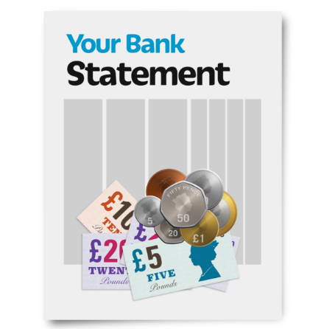 | The NHS will never ask you for information about your bank account or to pay for the vaccine.

