Community Integrated Learning Disability Service, Adults and Health Directorate, Nursing team
London Borough of Barnet, 2 Bristol Avenue, Colindale, NW9 4EW. Tel: 0208 359 6161 clcht.gpldnurse@nhs.net
My Pre-Health Check Questionnaire

My name is:

I like to be called:

My date of birth:

My telephone number:

We would like to share information about you with other health professionals. Is this okay?
or

Did anyone help you fill in this form?

or

My first language is

Do you have any difficulty communicating?

or

I communicate by: (tick as many as you like)
Talking
Signing
Using a communication aid
Pointing
Using gestures
Other (please specify)

I can understand information if it is:
Written word
With pictures
Communicated verbally
Interpreted by a carer
Other (please specify)

My next of kin is:

My main carer is:

I live with:

Do you see anyone from the Learning Disabilities Team?

or
Name:

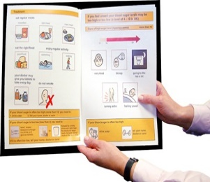 | Do you have a health action plan?
 |  | or
 | Do you have a hospital passport?
 |  | or
If you do, please bring them to your health check appointment

Do you have any allergies?

or
If yes, please list your allergies:

Do you have any problems taking your medication?

or
Do you take any over-the-counter medication?
or

Do you have any medical fears or phobias e.g. blood samples taken, blood pressure checks, injections?

or

Do you have any problems with your teeth or mouth?

or
When did you last go to a dentist?

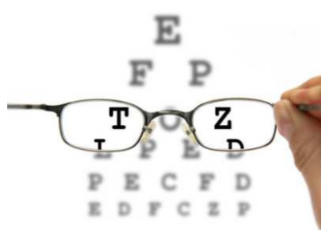 | Do you have any problems with your vision?
 |  | or
 | When did you last go to an optician?

Do you have any hearing difficulty?

or
Do you wear a hearing aid?
or
Have you had your hearing checked?
or

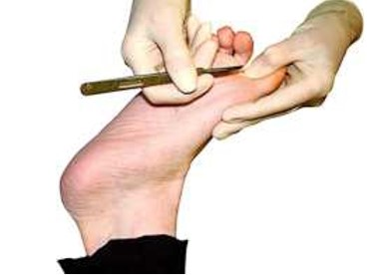 | Do you have any problems with your feet?
 |  | or
 | Do you visit a podiatrist?
 |  | or

Do you have any problems with your mobility?

or
Do you use any mobility aids e.g. wheelchair, stick or frame?

or
Do you see a physiotherapist or an occupational therapist?

or

Do you have any problems with eating and drinking?

or
Do you see a dietician?

or
Do you have any problems with swallowing?
or
Do you see a speech and language therapist?
or
Do you have any heartburn or indigestion?
or

Do you have any problems going for a poo e.g. constipation or diarrhoea or incontinence?
or
Do you have any problems going for a wee e.g. pain, blood or incontinence?
or

Do you have epilepsy?

or
If yes, how many seizures have you had in the last month?

For men and women aged 60-69

Have you been sent a kit to test for bowel cancer?

or
When did you last do the test?

For men

Has there been any pain or swelling in your testicles?

or

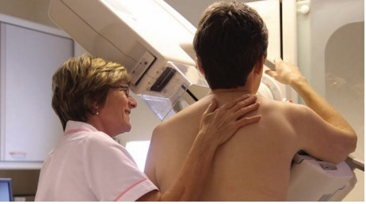 | For women  Have you noticed any pain or lumps in your breasts?
 |  | or
 | If you are over 50 when did you last go for breast screening?

For women aged 25- 64

Have you had a cervical smear test?

or
When was your last test?

For women

Do you have periods?

or
Any problems with your periods e.g. heavy, painful irregular?

or
Do you have any vaginal discharge that is smelly or makes you sore?

or

Would you like advice on safe sex and contraception?

or

Would you like advice on healthy eating?

or

When did you last have a flu vaccine?

Do you drink alcohol?

or
How much alcohol do you drink?

Do you take any recreational drugs?
or

Do you smoke?

or
If yes, how much do you smoke?

How are you feeling?

Is there anything you are worried about?

Anything else you would like to talk to us about?

Thank You for Taking Time to Complete the Form
Community Integrated Learning Disability Service, Adults and Health Directorate, Nursing team
London Borough of Barnet, 2 Bristol Avenue, Colindale, NW9 4EW. Tel: 0208 359 6161 clcht.gpldnurse@nhs.net

