Template for easy read letter
Address 1

Your NHS Number: XXXXX
Date:

Address 2
Address 3
Address 4
Postcode

Book your coronavirus (COVID-19) booster vaccine appointment now

Dear XXX
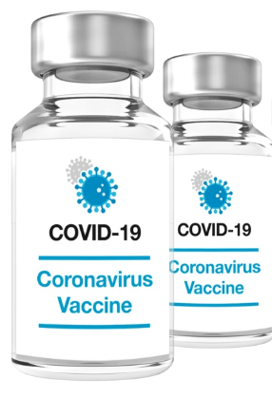 | It has been six months or more since you had your second coronavirus vaccine.
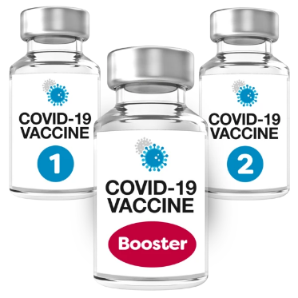  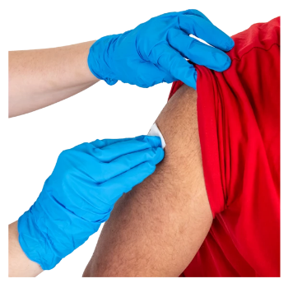 | The NHS thinks it is important for you to have a third coronavirus vaccine. This is sometimes called a COVID-19 booster vaccine or a coronavirus booster vaccine.
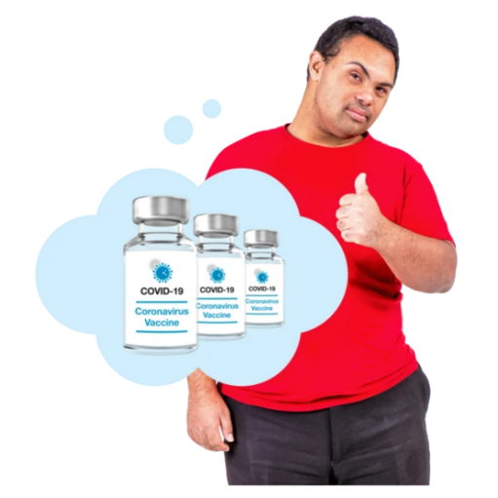 | It is important that you have your coronavirus booster (third) vaccine to make sure you are kept as safe as possible this winter.
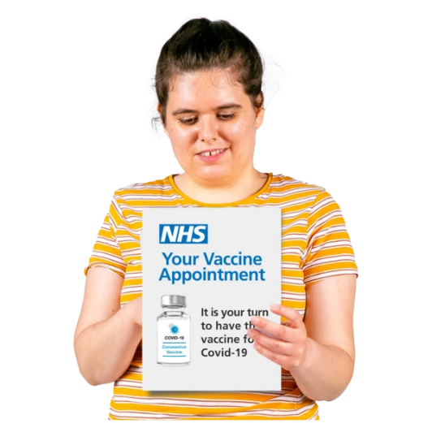 | This letter shows you how you can book your appointment.
 | If you already have an appointment booked, you don’t have to do anything.
How to book your appointment
 | There are 2 ways to get the coronavirus booster vaccine that we will explain more about in this letter.
- Booking at your doctors’ surgery
 | You can have your vaccine at your doctors’ surgery. You can ring them to book an appointment.
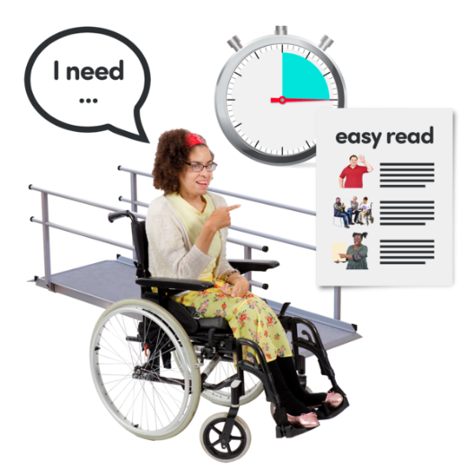 | Your doctors’ surgery should be able to make reasonable adjustments for you.
You can ask someone you trust to do help you book your appointment or to do it for you.

What will happen when you book your appointment?
The person you contact will ask you:

- Your name and date of birth.

- Your NHS number, this can be found at the top right of this letter.

It is a good idea to have this information ready to tell them.
When you book your appointment, you should tell them that you have a learning disability.

Please let us know if you need someone who speaks your language.

You can also tell them about any reasonable adjustments you need at your appointment. This might be:

 | - A longer appointment.
 | - Somewhere quiet to sit whilst you wait for your appointment.
 | - Support if you are worried about having the vaccine.
 | - Asking for someone to read any information to you or write down information for you.
 | - to have support from the NHS British Sign Language service. You can also get this by going to www.interpreternow.co.uk/nhs119
The person on the phone will tell you

 | - where your appointment will be
 | - the time of your appointment
 | They may ask you if you want them to send you, your appointment time by text or email.
2. Booking to have your booster vaccine through 119
 | If you don’t want to book to have your vaccine at your doctors’ surgery you can book through 119.
119 | If you do this your appointment will either be at:
 | - a larger vaccination centre
 | - or at a local pharmacy (Not all pharmacies offer the coronavirus booster vaccine, so any appointment must be made via 119).
 | Larger vaccine centres are often noisy and busy and they may not be able to offer the reasonable adjustments you need.
 | So you might want to go to your doctor for your coronavirus booster vaccine instead.
 | But if you do want to go to a large vaccination centre or pharmacy you can book through 119:
 | - go on the NHS website at www.nhs.uk/covid-booster
119 | - or ring 119 for free. You can ring them from 7am to 11pm any day of the week.
Can I book my vaccine appointment | - or text this number 18001 119

When you go to your vaccine appointment
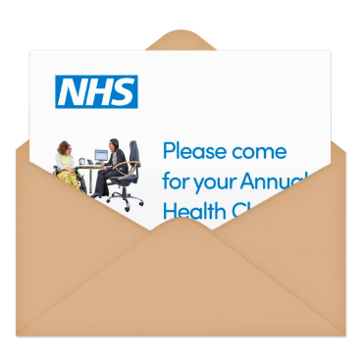 | You will need to make sure you have:
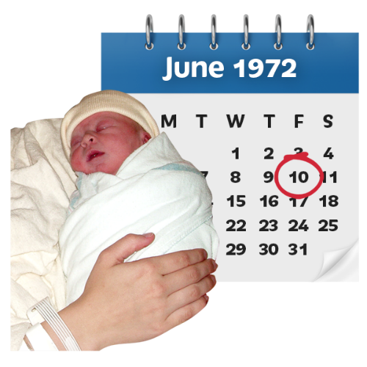 | - Your date of birth
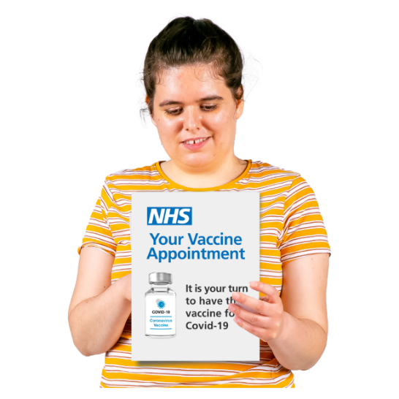 | - Your NHS number, which can be found at the top of this letter
 | When you go to your appointment, you should remind them that you have a learning disability and tell them about the reasonable adjustments you need.
 | Please bring this letter with you to your appointment.
About the coronavirus booster vaccine
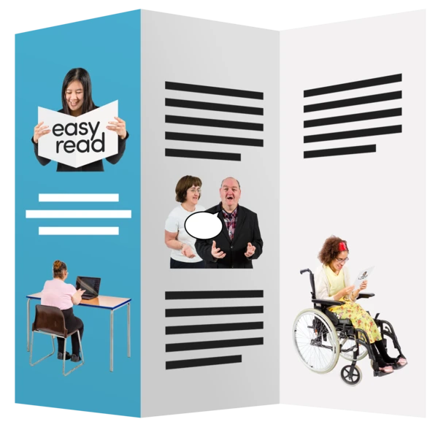 | If you would like more information you can look at the leaflet attached to this letter or go to bit.ly/covid-booster
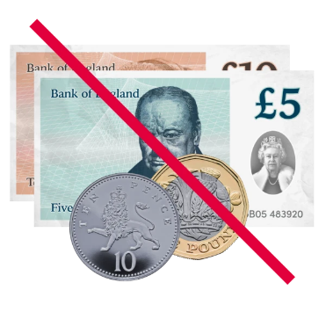 | The vaccine is only available from the NHS and is free.
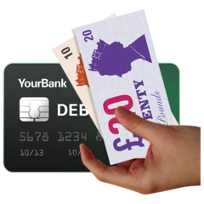 | The NHS will never ask you for your bank account details or to pay for the coronavirus vaccine or your flu vaccine.
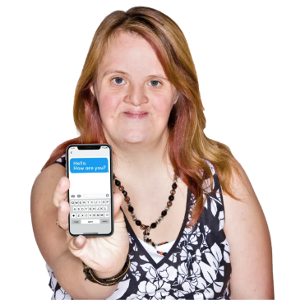 | The NHS may give you a phone call (which will come from 0300 561 0240) or a text message which will show up as ‘NHSvaccine’ reminding you to book your booster vaccine. Your doctor may also send you separate text messages.
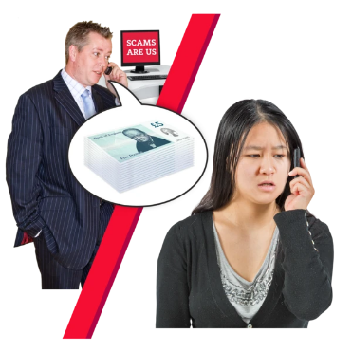 | If you get any messages, calls or emails asking you to pay for it, even if it looks like it is from the NHS, it will be a scam and you should not give them any of your information.
Flu vaccine

 | As well as having the coronavirus booster vaccine, it is also very important for you to have the flu vaccine to make sure you are kept safe from flu.
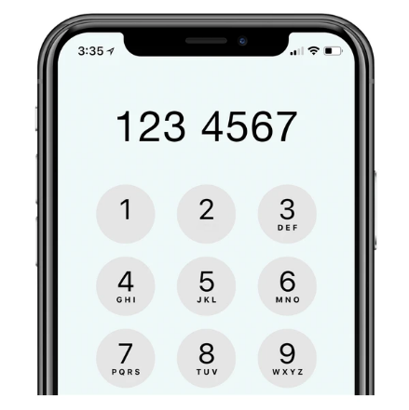 | You cannot book your flu vaccine using 119.
To find out how you to book your flu vaccine if you haven’t had one already, please go to
bit.ly/flu-easy-read

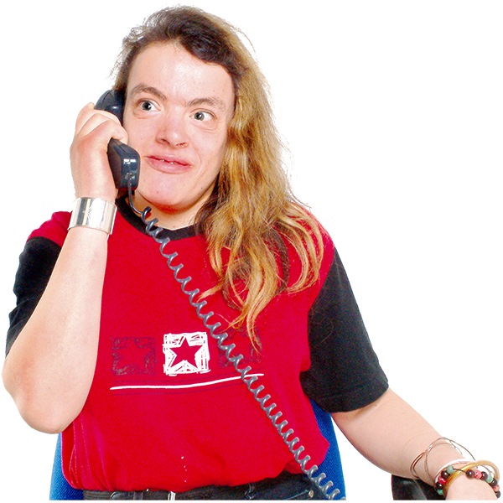 | You can contact your family doctor (GP) and some local pharmacies to arrange an appointment.
To get more information about the flu vaccine use the links below.

www.nhs.uk/fluvaccine

bit.ly/flu-easy-read

If you want to hear more about why it’s important to get your vaccine, you can watch these short videos.

Information about vaccines: For people with a learning disability and autistic people – YouTube – bit.ly/vaccine-info-video

Flu vaccinations for people with a learning disability - YouTube – bit.ly/flu-vaccinations-video

